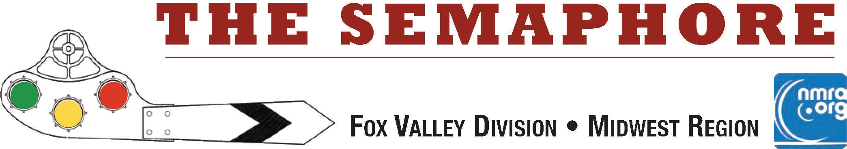

April 2023

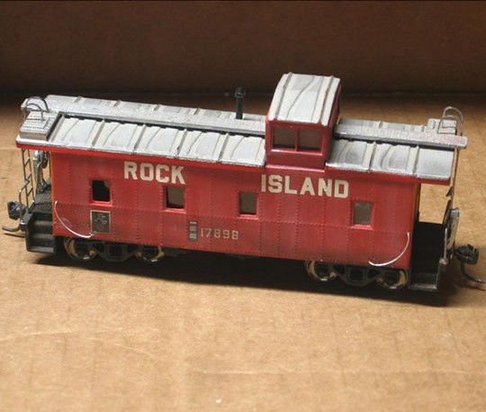The process used to weather this caboose will be the subject of the April FVD meet clinic. John Drozdak will be on site to show us his techniques for using PanPastel® materials. PanPastel® colors are professional, artists’ quality, soft pastel colors packed in a unique pan format (cake-like). Their special qualities mean that artists can blend and apply pastel (dry) color like paint for the first time. PanPastel® were originally made for painting, drawing and mixed media, but as you can see, they are an excellent material for hobby applications.

You will want to make plans to attend the meet in person to see this live demonstration up close. If you have an interesting car you would like to weather - bring it along for a demo!

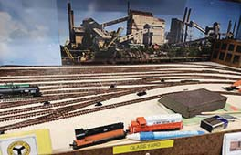Don't forget that the Fox Valley Division has the annual election of officers just around the bend at our Annual FVD Business meeting on April 16, 2023. The 2 year terms for Assistant Superintendent and Paymaster are up, and we will vote to fill these 2 year terms at that meeting. Reports from all the Trainmasters will also be on the meeting agenda.
In This Issue...
Page 1
Page 2
Page 2-4
Page 5
Page 6
Page 7
Page 8
Page 9
Page 9
John Drozdak's weathering
Keep those trains moving Chicago Industrial Scenery Mike's Minute & Fun Stuff Contest Results & Next Meet What's Happening (or not) Meeting Schedules
Help Wanted! Division Information

Keep those Trains Moving by Jim Osborn, MMR®...

So far, we have two candidates interested in these two positions: Denis Zamirowski for Assistant Super, and Rich Sieben for Paymaster. Their biographies appear in the March Semaphore. Nominations will also be accepted from the floor at the meeting.

Take care; stay safe, And Keep Those Trains Moving!
Jim Osborn, MMR®, Editor

Improvements to the Chicago Industrial Terminal by Rich Sieben

The N-Scale layout was ‘completed’ a year ago in January 2022. I like to run a new section for at least a year before putting down scenery in case I want to change something. Therefore, my yards have tended to grow with each expansion as I find that the traffic pattern works out a little different than I at first thought they would. I will include some ‘before’ and ‘after’ pictures of scenery progress.
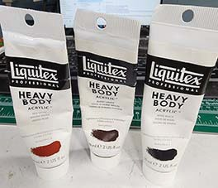
The first piece of work is to "rust" the rails. I did this with a paintbrush and 3 colors of thick latex paint. The colors are 2 parts red oxide, one part burnt sienna and one part ivory black.

Scenery is an additive process, and I keep adding layers of material until it looks "right." After I am satisfied with the track arrangement, I put ballast down. I had started using woodland scenic ballast on the first part of the layout and then discovered I had two containers of leftover filter sand from my old swimming pool. The granules are the right size of N scale, but it is white. I wanted a gray color, so I made a mix of half Paynes gray and ivory black and mixed it into a mix of 50/50 white glue and water with a drop of dish soap to break surface tension. I use a dropper to fill the area between the rails and it soaks out to the sand along the sides of the track. I found that adjusting the color of the mix to a battleship gray worked well with the white sand. Use more Paynes gray if you want it to look bluer, I found that out by accident!
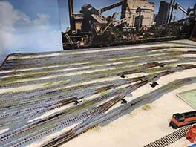
I work on each section as its own art project, so let’s take the example of a track along a field area. Start by applying white glue to the area making sure coverage is as even as you can get it. From years of walking secondary and industrial tracks, I noticed the area next to the track is typically fine particles and dirt. I lay woodland scenic "soil" right next to the tracks as the first layer (about half and inch wide). Next, I put down burnt grass further out with

some overlap on the "soil." This has the look of an area that has been hit with the weed sprayer in the spring. As I work away from the track, I use lighter and greener turf colors.

The next layer is tall grass. I use a yellow or straw color next to the tracks (remember the weed sprayer) and then use greener colors as I move away. The static grass is NOT applied using a static grass applicator because it makes the grass too uniform. Instead, I take a pinch of the grass between my index finger and thumb and push it into the wet glue. Some stays behind and is pointed generally upward. It looks more like wild grass than statically applied grass. It's familiar in look to grassy fields I have walked through.

Finally, it is time for bushes and maybe even trees. (I expect to add some more trees at some point). I use two colors of bushes and foliage and add a few pieces of lichen to look like larger areas of brush. After the glue dries, I vacuum up all the loose bits of grass and bushes.

Natural scenery changes all the time. It can change on your railroad as well. You can add or subtract as you experience the scene while using the railroad.

The picture at the top right of this page is a "finished" Glass Yard scene. I am really pleased with the final result.

I have included a couple of more "before and after" pictures.

A picture of "fresh" track laid out in January 2022 is at the lower right. My Swing Bridge is at the lower left of the picture with the pliers laying on the track board.

The following page shows the ballasted Swing Bridge before and after fresh scenery is added to the Bridge.
Careful! The glue is still wet in the photo.

I'll finish up with the new track-work at the Glass Plant shown before the scenery layers and then the "after" photo. The scenery process is fun, and it makes an amazing improvement in the look of your pike. Give it a try.

Rich Sieben

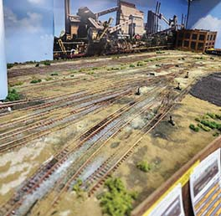
Finished Glass Yard scene.

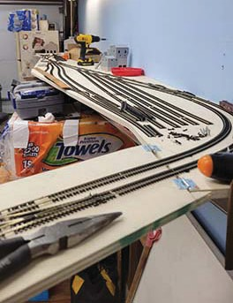
Bare trackage at the end of the Swing Bridge.

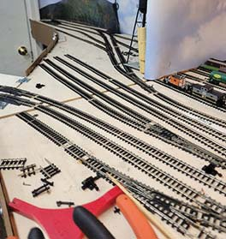

Ballasted Swing Bridge track.

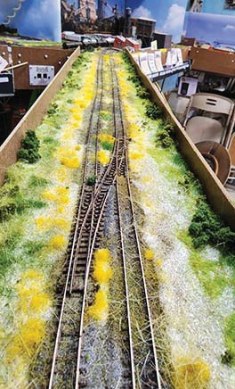

Finished Swing Bridge.
New Glass Plant track.
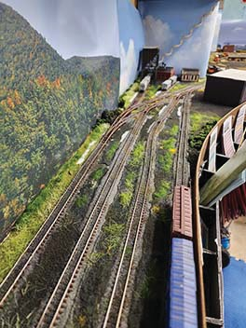

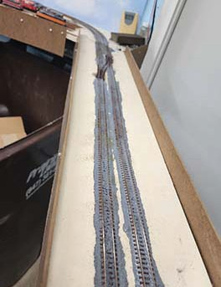
Finished Glass Plant area.

Mike's Minute ...
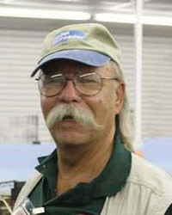
At our monthly meeting on March 19th, we had 17 members present at the Morava Center in Prospect Heights plus another
17 over the ZOOM computer system. NMRA National President Gordy Robinson, logged in from the Orkney Islands on the northern end of the UK. Truly, we are an international organization that touches every part of the world. Sometimes, we
don’t think of ourselves in that manner. Most of us just think local. But really, we (the NMRA) have an international presence. Example: NMRAx video programs originate in Australia and have featured modelers from several European, South American, African, and Asian countries. I hope our monthly gatherings have presented interesting and informative topics and have encouraged you to tell others about the division and the NMRA. We need to gain more diverse members to keep the division viable.

Last month I noted we had RR items on display in the Mt. Prospect Public Library. This year we were fortunate to be able to use the display case by the main entry for months of January and February. We were pleasantly surprised to also be able to use the display case in the meeting room for March. The library staff has been very complimentary about our displays. We hope to be able to exhibit again in 2024. My thanks to those members who loaned equipment and / or display items for this effort. The library ladies tell me we have the best display of any they have during the year.

Speaking of the year, we have our Annual Meeting of the Members on April 16th Election of officers (Asst. Superintendent and Paymaster) will be held. Our organization runs with volunteers and I sincerely thank those who have stepped forward to hold office or be a Trainmaster or contribute even in smaller ways. We do need of an Editor for our Newsletter, The Semaphore. Jim Osborn has filled in as 'temporary' editor for two years along with his other NMRA duties. It is time for a change. Without an editor, we may have to make some hard decisions on the news-letter. So, my challenge to the members is: who is willing? Is it YOU? Don’t let the train leave the station without you.

In other division news, now that we have welcomed spring back into our area, there are several opportunities coming up to get out and enjoy the fresh air. Please check out the Happenings list. There are a number of events on April 1 and 2, with more in April and into May. Choices, choices....

Our FVD meeting notices come out via e-mail before our meeting date, so please be sure we have your current e-mail address and advise of any change. Our webmaster sends out the meeting notice with the ZOOM system log-on credentials to make it easy to use the Zoom system if you’d rather participate that way. Whichever method you select to participate, I appreciate you taking the time and effort to attend.
You can see the full schedule, clinics and contest topics at:
https://www.foxvalleydivision.org/fvd2016/timetable.v2.html

Regards, Mike Hirvela, Superintendent

Fun Stuff by Jim Osborn, MMR®...
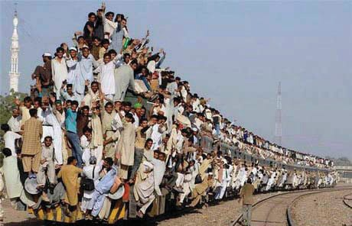
Excuse me, is this seat taken?

My past business travels have taken me to India many times and I did have a chance to ride several trains. I never saw a sight like the one pictured above, but I did see locals clamoring up on top of the coaches while the train was loading the paying riders in the station.

That brings to mind an experience at the New Delhi station. When you are a foreign traveler arriving at the station you get a local porter to carry your bag to make sure you get on the correct train and in your reserved seat. My porter brought me to the platform as promised. Being a train buff, I kept walking over this white line on the platform - about 5 feet from its edge to view the approaching train. Quite a safety margin I thought
- and paid no attention to the line. The porter kept pulling me back across the line. I assured him I was okay and kept
watching. Then he roughly pulled me back just before the train rumbled into the station.

What I did not appreciate was the real purpose of the white line: as the train rolls in, thousands of pigeons roosting in the platform grid-work above drop their stored poop and all fly off. What a mess the porter saved me from. YES, copious quantities of blue, gray & white pigeon poop landed on the far side of the white line.

What was even more amazing was how quickly the station crew came out with water hoses to wash the pigeon poop off the platform and sides of the coaches. It was all very organized. Clearly this happened on a regular basis. Needless to say, I gave the porter a generous tip.

I have traveled all over the world, and I can tell you that there is no place like America! It was always great to get home. J. O.

Next Meet - April 16, 2023, 1:30 start. In person at the Gary Morava Center and via Zoom.

Clinic Presentation: Weathering with PanPastels® by John Drozdak - Live and in-person!

Annual Business Meeting and Election of Officers

Check the FVD website Timetable for details and updates as they become available.
https://www.foxvalleydivision.org/fvd2016/timetable.v2.html

The March contest featured Billboard Reefers

We had 5 entries this month. Denis Zamirowski's, HO Scale, Kit "Dairy Products Pennsylvania Line" reefer took 1st place in the popular vote. The kit-built HO Scale "Raskin Packing Company Reefer" entered by Jim Osborn placed 2nd. We had a tie for 3rd place with the HO Scale kit built " Riddle Coach & Hearse Co. billboard car" by Patrick Martin and George K's TT Scale, 'Laderach Refrigerator Car'.
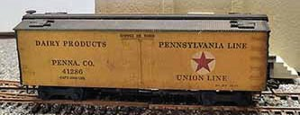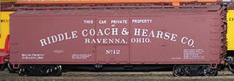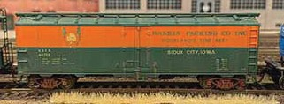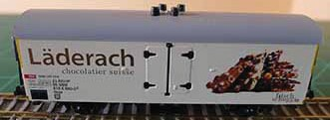

See more - and larger - photos of all the models on our web site at:
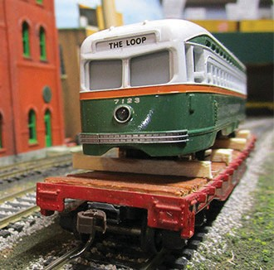
https://www.foxvalleydivision.org/fvd2016/contests.v2.html

The April Contest Category is A Freight Car with an Open Load. Here's last year's contest entry by Superintendent Michael Hirvela. Let your creative juices flow with this contest category. Open loads can always be fun!

Send in up to 3 photos of your models anytime using the our secure upload form:

https://form.jotform.com/201995250508962

What’s Happening - or not ...

The FVD will hold its Annual Business Meeting on April 16, 2023. The agenda will include reports from each Trainmaster and the Election of the Assistant Superintendent and Paymaster. Contact the Rich Hok- er, Chief Clerk if you are able to run for either of these offices. Contact him at: http://www.foxvalleydivision.org/fvd2016/contactus.v2.html
The meet will be live and also broadcast on Zoom. See the Division Time Table for details.

A DAY FOR THE ARCHIVES, at VFW Post 1197, 645 S. River Street (IL Rt3 25), Batavia, IL, - April 1; 9 am.
Sponsored by the BRHS, CNWHS, GNRHS, Lake States, MRHA, Shore Line and SLHTS. Presentations, company stores for the historical societies, buffet dinner. Click on the link to read an informative flier. https://www.foxvalleydivision.org/fvd2016/imagesfvd2016/events/2023archiveflyer.pdf
The USPS has issued a sheet of forever stamps featuring vintage train stations. You can see the sheet's image at: https://store.usps.com/store/product/buy-stamps/railroad-stations-stamps-s_483904
Great Midwest Train Show (aka: the Wheaton / DuPage Swap Meet) is under new management and is holding swap meets at the DuPage County Fairgrounds in Wheaton, IL. The dates for future shows are generally on the 1st Sunday: April 2, May 7 and June 4. Follow the signs to the fairgrounds entrance. See: https://www.trainshow.com/
The Lake County Model Railroad Club Open House in Wauconda, IL April 15-16, 2023

https://lcmrr.org/
The Illinois Railroad Museum in Union IL is celebrating their 70th year in existence in 2023.
https://www.irm.org/
David Leider, past FVD member and Midwest Region, Waybill editor has released a new book. It's titled, The Chicago & Western Indiana and Belt Railroad History. Click on the link for information & ordering. https://www.foxvalleydivision.org/fvd2016/imagesfvd2016/events/cwiflyer1.pdf
Work begins on the UP Challenger #3985. Click on the link to read the Trains Magazine story.
https://www.trains.com/trn/news-reviews/news-wire/work-begins-on-union-pacific-challenger-no-3985/
There will be no Midwest Region Convention scheduled for 2023.
The Title Town Train Show will be held on April 1-2, 2023 at the KI Convention Center, Green Bay, WI.
Please see: https://www.ttsgbllc.com/ for all the details.
The Thousand Lakes Region Convention. May 18-21,. 2023. Best Western Plus Bloomington- Mall of America -- Bloomington, Minnesota https://www.thousandlakesregion.org/2021-bismarck-con
Franklin Park Railroad Daze June 10. https://www.villageoffranklinpark.com/events/railroaddaze/
The St. Louis Railroad Prototype Modelers Meet July 28 & 29, 2023. https://www.stlrpm.com/

The 2023 NMRA National Convention - The Texas Express - August 20 - 26, 2023 Gaylord Texan Resort & Convention Center, 1501 Gaylord Trail, Grapevine, TX 76051 https://www.2023texasexpress.com/
The resurrected Naperville RPM will once again be held in the Chicago area. The dates are October 27 and 28, 2023.

2022-2023 Fox Valley Division Meeting Schedule
Page 8

Meetings are held from 1:30 to about 4:00 pm (except as noted). This season all meetings will be pre- sented online using ZOOM meeting technology as well as in person at the Gary Morava Center. See the timetable on the division’s web site http://www.foxvalleydivision.org/fvd2016/timetable.v2.html for complete instructions on how to use ZOOM and participate in the meetings. For the latest clinic updates and all FVD news and information, visit FVD’s web site at www.foxvalleydivision.org. Save the dates for now - details will follow.

Date

Nov 20, 2022

Dec 18, 2022
Presentation

Grain & Railroads by Mark Vaughan

Two Prototype Steam Engine Overhauls by Chuck Rita
Contest

1 “Over, Under, Around, or Through.”

1 Steam Locomotive.
Notes

Jan 15, 2023
Simplified use of the NCE Switch 1 Diesel Locomotive.

IT-2 and the Switch IT-8 for non- tech folks!
by Mike Wood

Feb 19, 2023

Mar 19, 2023
Interchanges by Scott Payne

Two Prototype Steam Engine Overhauls by Chuck Rita
Rail Yard Sale - bring your stuff to sell and cash to buy more.
1 Illuminated structure.

1 Refrigerated billboard car.

April 16, 2023

Next Meet
Annual Business Meeting and Election of Asst. Superintendent and Paymaster Please contact the Chief Clerk if you are able to run for either of these offices.

May 21, 2023
Presentation: Weathering with Pastels by John Drozdak

History of Cardboard Structures
by Dave Lull
1 freight car with an Open load. 1 structure.

Submit Your Contest Photos anytime at: https://form.jotform.com/201995250508962

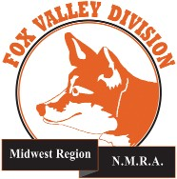
Page 9
More Help Wanted ....
The Temporary Semaphore Editor is retiring in May after his 26th issue has been published. Benefits: Fun job , express your creativity, meet other folks in the hobby, work with contributors, improve your spelling, learn stuff, flexible hours and no pay. Interested in keeping the Semaphore alive? Contact the Semaphore editor or any officer at:
http://www.foxvalleydivision.org/fvd2016/contactus.v2.html
The Semaphore is published by the Fox Valley Di- vision of the Midwest Region of the NMRA once a month, ten months a year, from September to June.
The Fox Valley Division of the Midwest Region of the NMRA is registered 501(c)7 not-for-profit Illinois corporation.
About the Fox Valley Division
If you receive this newsletter, you live in the Midwest Region and Fox Valley Division area of the National Model Railroad Association or NMRA. The Fox Valley Division (FVD) includes all of Lake and McHenry, as well as parts of Cook and Kane Counties in northeast Illinois. About 180 members of varied ages and mod- eling ability levels belong to the FVD. Almost all mod- eling scales are represented in our division. Subscrip- tions to the Semaphore newsletters are free. NMRA membership in the division is available through the NMRA at:
https://www.nmra.org/
2022 –2023 FVD monthly meetings are held Septem- ber through May on-line via the ZOOM virtual meet- ing technology per the schedule in this issue. Each meeting features a clinic, model contest, and infor- mation of interest to the membership. Outings, layout tours, and operating sessions may also be held when Covid-19 protocols allow gatherings.
We encourage you to take advantage of all the FVD has to offer. We are here to answer your questions, help improve your modeling, and help you better enjoy the great hobby of model railroading. Visit us on the web at: http://www.foxvalleydivision.org/

Mailing address:
Fox Valley Division
P. O. Box 1535
Arlington Heights, IL 60005-1535

Website:
http://www.foxvalleydivision.org/
Regular meetings are held virtually via Zoom and in person at the Gary Morava Center generally from 1:30 until 4:00 PM per the schedule listed in this publication and on its website at:
http://www.foxvalleydivision.org/fvd2016/timetable.v2.html
Editor: Jim Osborn, MMR® Assistant Editor: Michael Hirvela Assistant Editor: Keith Dart Contributing Editor: Rich Sieben
Follow us on Facebook:
https://www.facebook.com/fvdnmra/
Membership Services, Erich Abens Membership Promotions, Mike Hirvela Web Technologies, Jim Osborn
Public Relations, Keith Dart
Semaphore Editor, Jim Osborn Ways & Means, Vacant
Fox Valley Division Board of Directors
Asst. Superintendent, Denis Zamirowski Chief Clerk, Richard Hoker
Paymaster, Tim Kleimeyer Achievements & Contests, Jim Landwehr Clinics & Programs, Gary Saxton
Social Media Coordinator, Keith Dart
Superintendent, Mike Hirvela
Need to contact any BoD members? Click this link to:
http://www.foxvalleydivision.org/fvd2016/contactus.v2.html
©Copyright 2022 by the Fox Valley Division of the NMRA, Inc.

