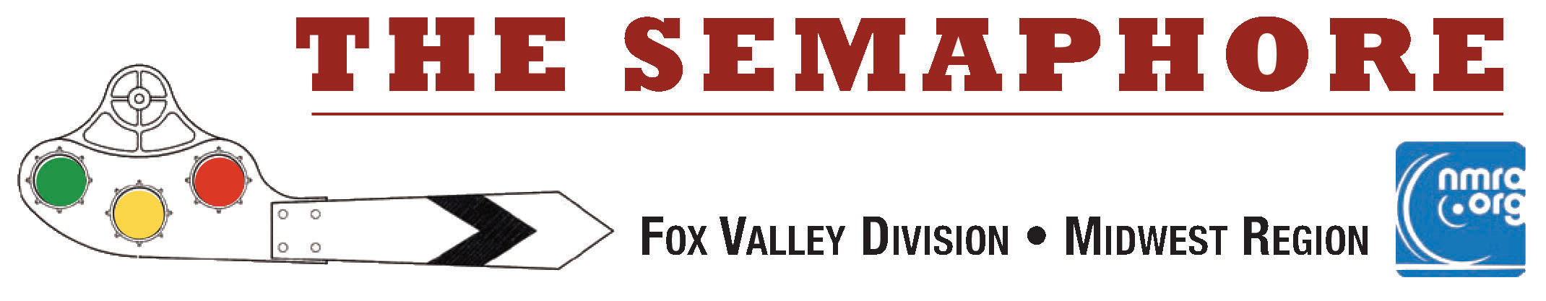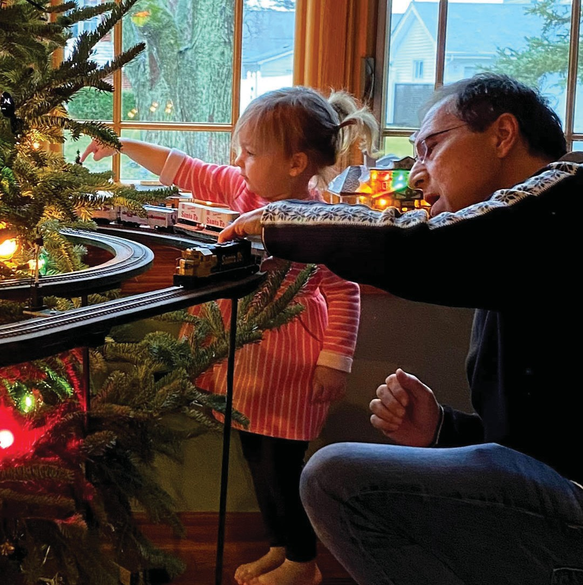February 2023
February 2023

Last month, Superintendent Mike Hirvela asked the division to send in a photo or two of their holiday train displays. New to the Fox Valley Division, Chris Mattimiro shared a photo of his "elevated" railroad running around and through their Christmas tree. It looks as though Chris' granddaughter is practicing her dispatching skills in the picture. I see a future model railroader there! Several more photos and a description of constructing the "elevated" RR follow on page 2.

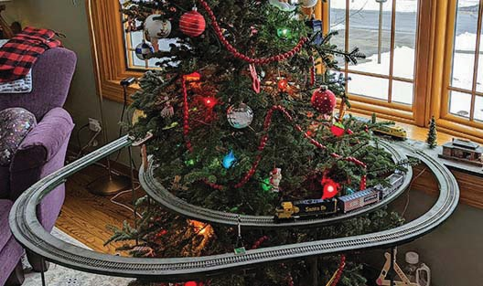
where all the presents go! With a bow window in the living room providing a few extra square feet of shelf, elevating (the EL) track seemed like a logical solution for my wants. There’s nothing very fancy about the layout. It doesn’t follow any historical prototype, but aims for a ‘Christmas décor’ style with green under-layment, decorated trees, and miniature wreaths.
In This Issue...
Page 1-3 Chris Mattimiro's Holiday RR Page 2 Keep those trains moving Page 2-5 John Acheson’s Santa Fe RR Page 6 Mike's Minute
Page 7 Contest Results & Next Meet Page 8 What's Happening (or not) Page 9 Meeting Schedules
Page 10 Division Information

Keep those Trains Moving by Jim Osborn, MMR®...
The Fox Valley Division got national recognition in the February NMRA Magazine. I was surprised to read a reference to my December Semaphore clinic on Making a Realistic Scale Red Maple tree in the NMRA@home news column on page 22 of the February issue. The tree has been "planted," and I am happy to report that the "leaves" are still red.

I want to make a few more trees after applying a few lessons learned from the first batch: 1) Remove as much chaff as possible before grinding the leaves and 2) Grind the leaves up smaller. I think that should make a better looking, to-scale tree.

FVD N Scaler, Keith Dart sent in a link to an article on getting started in N Scale with a simple module. Sometimes, it's a good idea to start small to find your interests. Read what Model Railroader Magazine has to say about that.

https://www.trains.com/mrr/beginners/ask-trains/getting-started-in-n-scale/

We have a special treat for the March Semaphore. Mark Llanuza has shared with us a number of winter prototype photos he has taken. Have your winter clothes and boots ready to view his dramatic pictures! One of his favorites graced the cover of last month's Semaphore. Brrr....

Speaking of cold - you'll like this story on catching a cold at the Illinois Railway Museum;
https://www.theautopian.com/i-caught-a-cold-visiting-americas-largest-train-museum-heres-why-it-was-totally-worth-it/

Take care and stay safe, Jim Osborn, MMR®, Editor

Holiday Train Display by Chris Mattimiro, FVD...
(Continued from the cover page) To me toy trains and Christmas are naturally associated with each other. I liked the idea of running the train around the tree, but not on the floor, because of course that’s

I started with a sheet of plywood, laid out the track pattern, then cut away everything that didn’t have track on it. It’s held up with dowel rods, the minimum number needed to support the track, the cars and the occasional cat that walks on it.
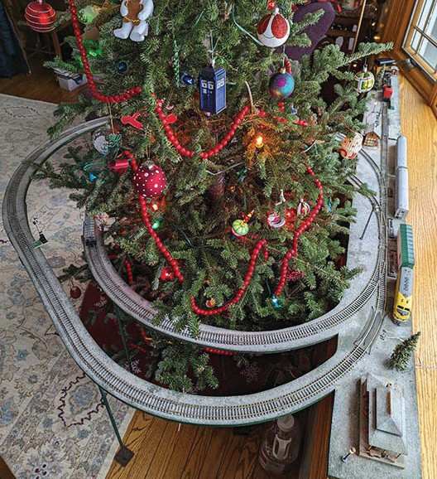
Just about everything on the layout came from the old Tyco set, with the exception of a couple buildings, passenger cars, and the newer Athearn loco. It replaced the original F9 Union Pacific when its gears seized up, which occurred about the time I sprinkled snow all over the place. That stuff gets into everything.

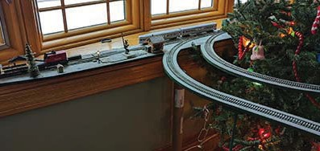

Holiday Train Display... Continued from page 2
With generation 2 in the planning, I’m aiming to make set- up and tear down easier by separating the layout into a few sections. I'll have a nicer, cabinet-grade platform and take advantage of the newer technologies to add multi- ple autonomous trains plus animation. Send me any ideas you may have. I am eager to learn more.

Contact me at cmattimiro@outlook.com C. M.

John Acheson’s Santa Fe, Argentine Division, 1st and 2nd Districts by Rich Sieben...

This is a sizable N scale layout I saw at the Kansas City Prairie Rail 2022 in operations event. It runs from Kansas City to Emporia -- focusing on the operations associated with the Argentine Division. The railroad's First and Second Districts meet at Emporia with all west traffic heading off from there. Eastbound traffic runs to Marceline, Missouri.

Jobs on the railroad include: Dispatcher, Argentine Yard Master, Yard Trim job (works with Yardmaster to work inbound and outbound trains), Yard Classification job (classifies all trains in the yard), Argentine Local job (local works Turner industrial park in yard limits), West Bottoms local (industrial switching job), Lawrence Local (works Lawrence, KS and 1st district industries), Olathe Local (a transfer Job) and various road jobs.

I have been to John’s layout before and gravitate to the yard jobs…because I like switching!

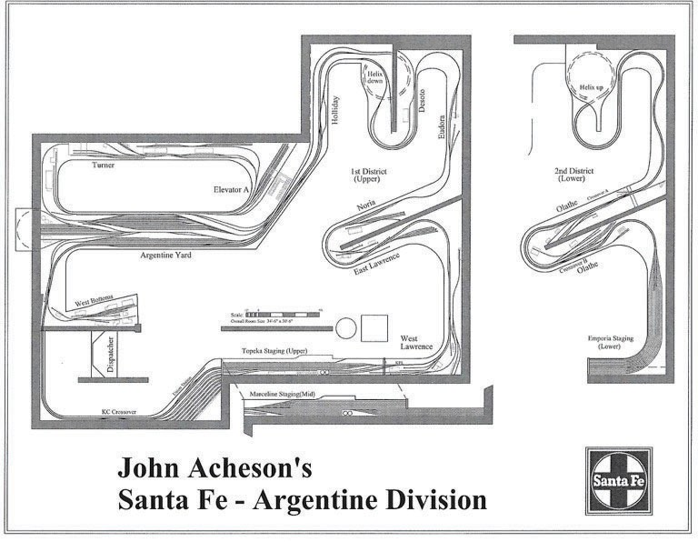

John Acheson’s Santa Fe continued.....

I took the Argentine yard classification job which is plenty busy. You no sooner get done classing a train when another one shows up. This, plus having to work with, and around the Argentine local job, keeps beads of sweat on your brow. The smoothness of operations on this layout is something to be proud of, and I am fortunate to have had another chance to run on this fantastic railroad.

Follow along with some pictures of the layout.
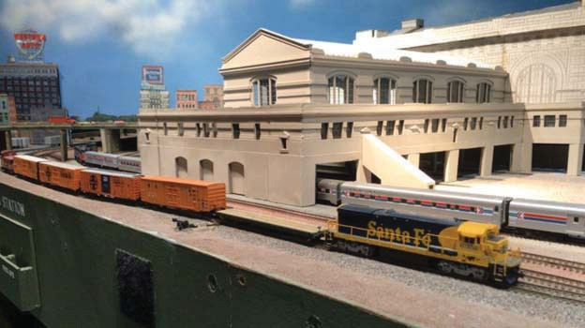
Amtrak’s National Limited at Union Station with the ATSF/MKT transfer headed back to Argentine yard
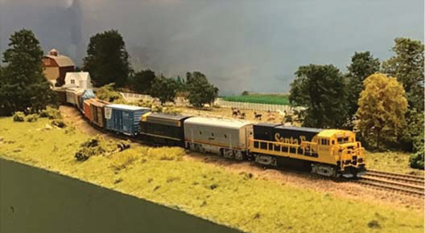
Westbound Peddler outside Noria
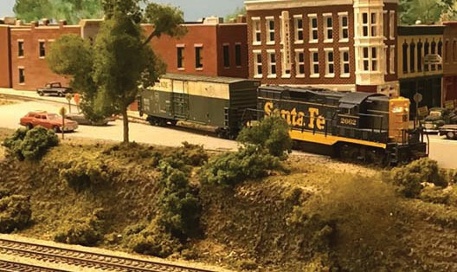
The Lawrence Local works downtown switching at the Journal World newspaper

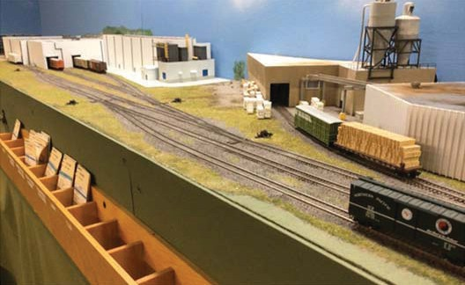
Argentine Local switches industries at Turner Industrial Park
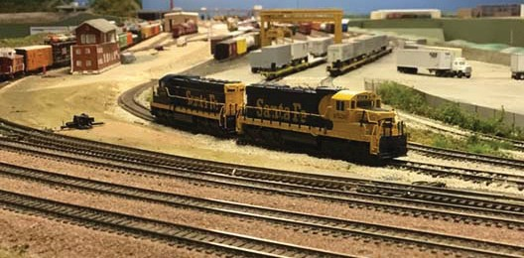
Argentine Yard and TOFC facility
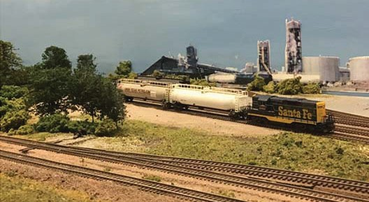
Lawrence Local at the Farmland Ammonia Plant
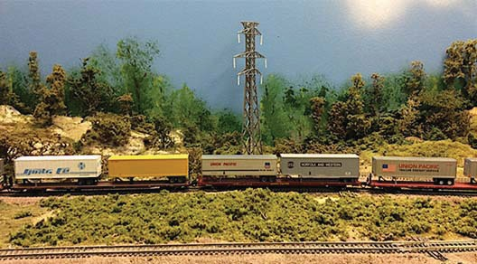
Eastbound TOFC towards Holiday on the 2nd District

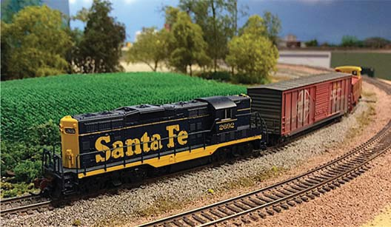
Lawrence Local outside DeSoto, KS
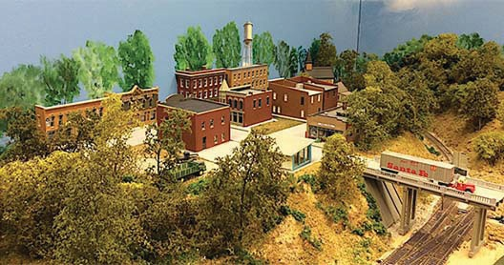
Bird's Eye view of DeSoto, KS
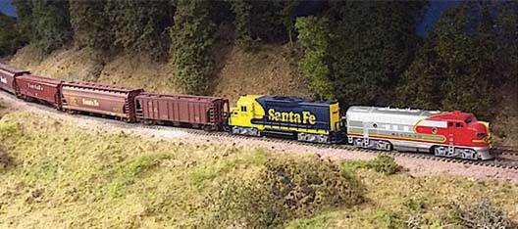
Westbound Grain Extra just east of Olathe
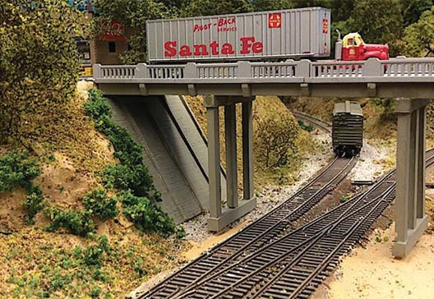
Track to Sunflower Ammunitions Plant at DeSoto, KS
Lawrence Local works the Farmland Industries at Noria
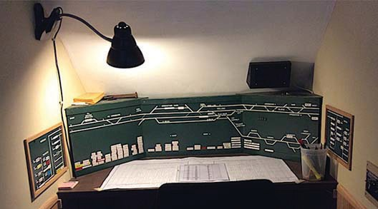
Dispatcher's Office

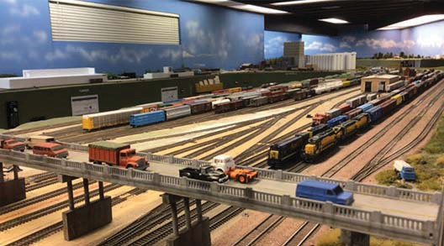
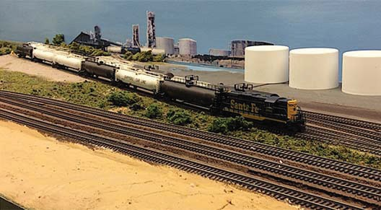
Argentine Yard

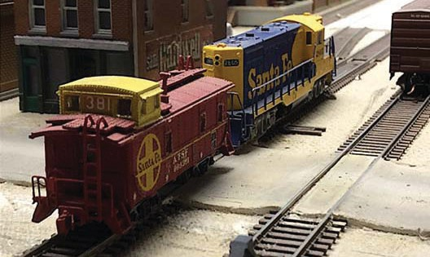

A view of the West Bottoms Local ends the photo tour.
Hope you enjoyed seeing the RR! R. S.

Mike's Minute ...
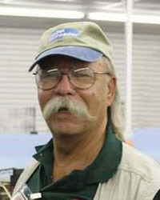
Our ‘hybrid’ meetings seem to be going well. In January, we did some manual shifting from the power point slides to live-in-front-of-the-camera and back again several times. We owe a thank you and a "well done" to Mr. Osborn for his manipulation of several magic boxes at the same time.

Mike Wood’s presentation on the North Coast Engineering Switch-Its MK 2 and MK 8 boards for turnout control was probably the busiest as far as equipment usage goes, but I think it was necessary for clarity. I hope the presentation came across clearly and understandably. Mike’s slides and handout sheets are available on the FVD website clinic presentations' webpage so you can review the information at your leisure. Digital technology advancements have really gone further than I realized. You can grab the clinic and/or notes here: http://www.foxvalleydivision.org/fvd2016/clinics.v2.html

As I noted last month, we have a display of RR items in the main lobby display case at the Mt. Prospect Public Library. We had items in the case for January and will have other items in the case for February. Additionally, the library offered us their meeting room display case for March. It is a 3-section case of about the same size. So, we have two more chances to show our best. If you have an item
- be it a special car, locomotive, a sign, plaque, or some kind of railroadiana - let me know to expect you at the Mt. Prospect Public Library when we change the main lobby display items on January 30 about 10 am. The date for the load-in for the meeting room display case will be forthcoming.

Our long-time Paymaster, Tim Kleimeyer, has notified the BoD that he does not intend to run for the position in the upcoming Spring elections. So, we’ll need a new person to be responsible for our accounts and for paying the bills. You don’t need to be a CPA or an Accountant. The Paymaster is a voting member on the Board of Directors. Let me know if you are willing to stand for election and serve the division. Paymaster is one of the required positions that make us a viable division.

I want to remind everyone that the NMRA is a volunteer organization and we need member participation to keep the division running. Consider investing a little time help. There are additional positions available along with the Paymaster, Publications and Ways and Means Trainmasters. See the last page listing all the board positions.
At this time, we are planning on holding Hybrid In-person/ Zoom meetings for the entire season. Specific meeting notice details are sent out via e-mail one week before each meet, so be sure we have your current e-mail address on file and always advise of any changes. You can update your email address at:

http://www.mwr-nmra.org/mwr2016/mwr.address.change.html

Each monthly notice includes the ZOOM system log-on credentials to make it easy to access the Zoom system if you choose participate that way. Details on each hybrid meeting agenda are also listed on the timetable tab of our website and in each issue of the Semaphore.

http://www.foxvalleydivision.org/fvd2016/timetable.v2.html

Finally, I hope you had good holiday celebrations and are looking forward to bringing in the new year with new ideas. With the Mad City Train Show on February 18 and 19, I will be unable to run the division meeting on February
19. Our Asst. Superintendent, Denis Zamirowski, will host the meeting. I read ahead to the February clinic schedule and the presentation topic of ‘Interchanges’ sounds like a great way to apply “beyond the basement” operations to your model railroad. I'll see you next month!

Regards, Mike Hirvela, Superintendent
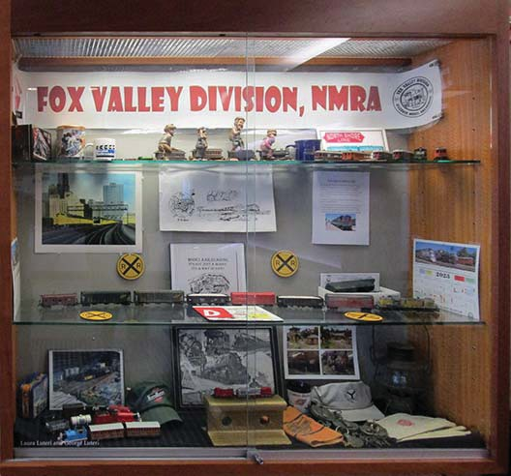
Here's a snap of the Mt. Prospect Library Display. Thanks to all who loaned us equipment and memorabilia -- and helped us put it together.

Next Meet - February 19, 2023, 1:30 start. In person at the Gary Morava Center and via Zoom.

Clinic Presentation:
Interchanges by Scott Payne. Scott will discuss the use of interchanges by the prototypes and then why and how we should incorporate them on our layouts.

Check the FVD website Timetable for details and updates as they become available.
http://www.foxvalleydivision.org/fvd2016/timetable.v2.html

The January Contest Results
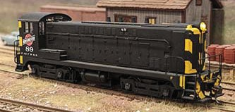
The January contest featured Diesel Locomotives. We had 8 terrific entries. See them all on the Contest tab of our web site. The link is listed below.

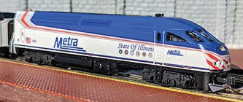
Jim Osborn's HO Scale, Kit Bash of a C. St. P. M. & O. Baldwin VO600 #89 with a custom paint job garnered the 1st place popular vote. The original loco was a Stewart CB&Q switcher.

Keith Dart's N Scale, Ready 2 Run, unweathered “State of Illinois” MP36PH Metra #402 by Kato is a DC powered locomotive. The unit took 2nd place.

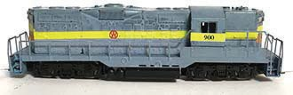
3rd place went to Gary Saxton's Z Scale NYO&W GP9 - Note the lower painted half of the shell is a custom Z scale laser printed decal made by Gary. A larger picture shows the Z scale gray/ white diamond cross hatching below the yellow stripe on the loco.

See more and larger photos of all the models on our web site at:
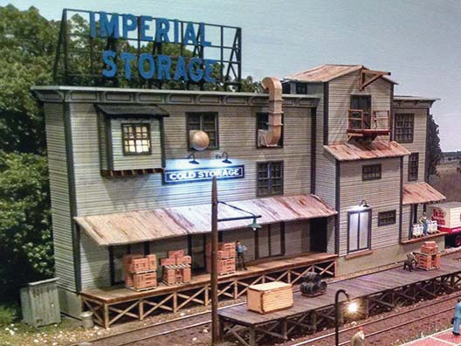
http://www.foxvalleydivision.org/fvd2016/contests.v2.html

The February Contest Category is all about Illuminated Structures. Here's an inspiration photo of a building with its interior and exterior lights on.

Send in up to 3 photos of your models anytime using the our secure upload form:

https://form.jotform.com/201995250508962

What’s Happening - or not ...

You'll enjoy this story on catching a cold at the Illinois Railway Museum.
https://www.theautopian.com/i-caught-a-cold-visiting-americas-largest-train-museum-heres-why-it-was-totally-worth-it/

The Illinois Railroad Museum in Union IL is celebrating their 70th year in existence in 2023.
https://www.irm.org/
The Fox Valley Division will be holding in-person division meets at the Gary Morava Center. The meets will also be broadcast via Zoom. See the next page for details on each meet. We hope to see you there!
Work begins on the UP Challenger #3985. Click on the link to read the Trains Magazine story.
https://www.trains.com/trn/news-reviews/news-wire/work-begins-on-union-pacific-challenger-no-3985/
Great Midwest Train Show (aka: the Wheaton / DuPage Swap Meet) is under new management and is holding swap meets at the DuPage County Fairgrounds in Wheaton, IL. The dates for future shows are generally on the 1st Sunday: Jan 8, 2023, February 5, March 5, April 2, May 7 and June 4. Follow the signs to the fairgrounds entrance. See: https://www.trainshow.com/
The Mad City Train Show, Alliant Energy Center, Rimrock Road and John Nolen Drive, (just off the 12-18 By-pass), Madison, Wis., February 18 and 19, 2023. https://www.nmra-scwd.org/scwd-events.html
There will be no Midwest Region Convention scheduled for 2023.
The FVD will hold its annual Rail Yard Sale at the March 19th meet. Bring your unwanted equipment and take this chance to relieve yourself of that extra inventory; find some new goodies and support the division. Name the prices on your items. The FVD will retain 10% of all the proceeds from items sold to help fund the division.
The Rock River Valley Division Train Show will be held on March 25, 10 am - 5 pm & 26, 10 am - 3pm, 2023 Harlem High School, North Alpine Road (south of IL 173), Machesney Park, IL.
The Title Town Train Show will be held on April 9-10, 2023 at the KI Convention Center, Green Bay, WI.
Please see: https://www.ttsgbllc.com/ for all the details.
The FVD will hold its Annual Business Meeting on April 16, 2023. The agenda will include reports from each Trainmaster and the Election of the Assistant Superintendent and Paymaster. Contact the Rich Hoker, Chief Clerk if you would like to run for either of these offices. Contact any officer at: http://www.foxvalleydivision.org/fvd2016/contactus.v2.html

The Thousand Lakes Region Convention. May 18-21,. 2023. Best Western Plus Bloomington- Mall of America -- Bloomington, Minnesota https://www.thousandlakesregion.org/2021-bismarck-con
The 2023 NMRA National Convention - The Texas Express - August 20 - 26, 2023 Gaylord Texan Resort & Convention Center, 1501 Gaylord Trail, Grapevine, TX 76051 https://www.2023texasexpress.com/

The resurrected Naperville RPM will once again be held in the Chicago area. The dates are October 27 and 28, 2023.

2022-2023 Fox Valley Division Meeting Schedule
Page 9

Meetings are held from 1:30 to about 4:00 pm (except as noted). This season all meetings will be pre- sented online using ZOOM meeting technology as well as in person at the Gary Morava Center. See the timetable on the division’s web site http://www.foxvalleydivision.org/fvd2016/timetable.v2.html for complete instructions on how to use ZOOM and participate in the meetings. For the latest clinic updates and all FVD news and information, visit FVD’s web site at www.foxvalleydivision.org. Save the dates for now - details will follow.

Date

Nov 20, 2022

Dec 18, 2022
Presentation

Grain & Railroads by Mark Vaughan

Two Prototype Steam Engine Overhauls by Chuck Rita
Contest

1 “Over, Under, Around, or Through.”

1 Steam Locomotive.
Notes

Jan 15, 2023

Next Meet
Simplified use of the NCE Switch 1 Diesel Locomotive.

IT-2 and the Switch IT-8 for non- tech folks!
by Mike Wood

Feb 19, 2023

Mar 19, 2023
Interchanges by Scott Payne

Presentation TBA
Rail Yard Sale - bring your stuff to sell
1 Illuminated structure.

1 Refrigerated billboard car.

April 16, 2023
Annual Business Meeting and Election of Asst. Superintendent and Paymaster Please contact the Chief Clerk if you are able to run for either of these offices.

Presentation: Weathering with Pastels by John Drozdak
1 freight car with an Open load.

May 21, 2023

History of Cardboard Structures
by Dave Lull
1 structure.

Submit Your Contest Photos anytime at: https://form.jotform.com/201995250508962

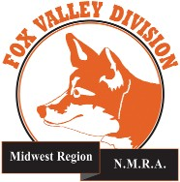
Page10
LET US KNOW IF YOU ARE OUT THERE ....
Send us your: Prototype or model artwork, images, cartoons, drawings, paintings photos, layouts, etc. We'll take care of the editing and formatting for the publication. Contact us at:
http://www.foxvalleydivision.org/fvd2016/contactus.v2.html The deadline for any issue is 1 week prior to the
1st day of the issue month.
The Semaphore is published by the Fox Valley Di- vision of the Midwest Region of the NMRA once a month, ten months a year, from September to June.
The Fox Valley Division of the Midwest Region of the NMRA is registered 501(c)7 not-for-profit Illinois corporation.
About the Fox Valley Division
If you receive this newsletter, you live in the Midwest Region and Fox Valley Division area of the National Model Railroad Association or NMRA. The Fox Valley Division (FVD) includes all of Lake and McHenry, as well as parts of Cook and Kane Counties in northeast Illinois. About 180 members of varied ages and mod- eling ability levels belong to the FVD. Almost all mod- eling scales are represented in our division. Subscrip- tions to the Semaphore newsletters are free. NMRA membership in the division is available through the NMRA at:
https://www.nmra.org/
2020 –2021 FVD monthly meetings are held Septem- ber through May on-line via the ZOOM virtual meet- ing technology per the schedule in this issue. Each meeting features a clinic, model contest, and infor- mation of interest to the membership. Outings, layout tours, and operating sessions may also be held when Covid-19 protocols allow gatherings.
We encourage you to take advantage of all the FVD has to offer. We are here to answer your questions, help improve your modeling, and help you better enjoy the great hobby of model railroading. Visit us on the web at: http://www.foxvalleydivision.org/

Mailing address:
Fox Valley Division
P. O. Box 1535
Arlington Heights, IL 60005-1535

Website:
http://www.foxvalleydivision.org/
Regular meetings are held virtually via Zoom and in person at the Gary Morava Center generally from 1:30 until 4:00 PM per the schedule listed in this publication and on its website at:
http://www.foxvalleydivision.org/fvd2016/timetable.v2.html
Editor: Jim Osborn, MMR® Assistant Editor: Michael Hirvela Assistant Editor: Keith Dart Contributing Editor: Rich Sieben
Follow us on Facebook:
https://www.facebook.com/fvdnmra/
Membership Services, Erich Abens Membership Promotions, Mike Hirvela Web Technologies, Jim Osborn
Public Relations, Keith Dart
Semaphore Editor, Jim Osborn Ways & Means, Vacant
Fox Valley Division Board of Directors
Asst. Superintendent, Denis Zamirowski Chief Clerk, Richard Hoker
Paymaster, Tim Kleimeyer Achievements & Contests, Jim Landwehr Clinics & Programs, Gary Saxton
Social Media Coordinator, Keith Dart
Superintendent, Mike Hirvela
Need to contact any BoD members? Click this link to:
http://www.foxvalleydivision.org/fvd2016/contactus.v2.html
©Copyright 2022 by the Fox Valley Division of the NMRA, Inc.

