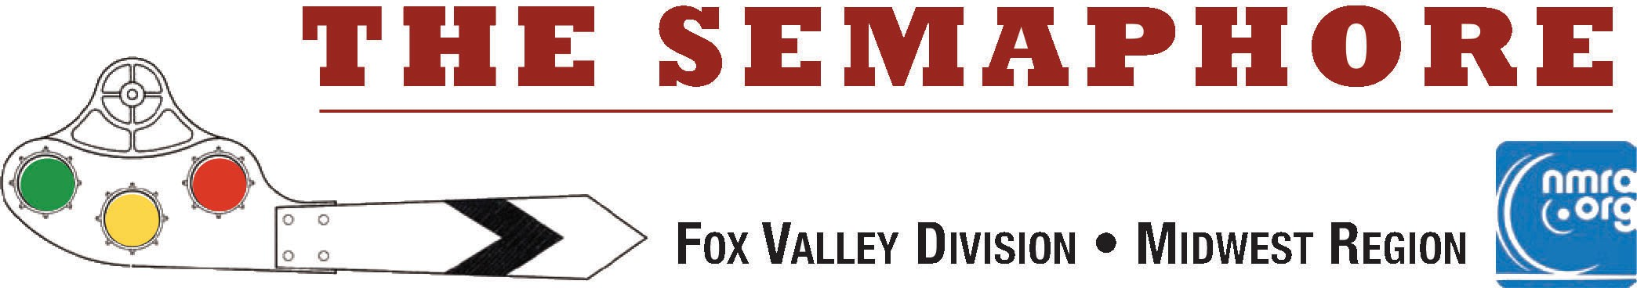

**May 2025**

|  |
| --- |
|  |
| **The April model Celebration had 1 diorama on display. An HO Scale Kit-bashed Fine Scale Miniatures Rural Lumber Mill title="HO Scale Kitbashed Fine Scale Miniatures Rural Lumber Mill (Modeler currently unknown) was the lone entry. Was it you? Let the webmaster know! Click on this link to see more photos of the model on display. h**[**ttps://www.foxvalleydivision.org/fvd2016/contests.v2.html**](http://www.foxvalleydivision.org/fvd2016/contests.v2.html) |
| ***In this issue:***  **Page 2: Comments from the FVD Superintendent, Michael Hirvela*.***  **The 2024-2025 FVD meeting schedule.**  **Page 3-5: IRM Division Outing. Page 5: Web links.**  **Page 6: Help wanted.**  **About the Fox Valley Division, the *Semaphore* & FVD Board of Directors.** |
| **Next Division Meet - May 18, 2025 at the Glenview Public Library - 2:00 start:**  **Clinic Presentation: Home Manufactured Track by Gary Saxton, FVD**  **The clinic will describe how to use a 3D filament printer to make tie jigs for traditional and dead rail track, switches and specialty items. Examples of Z, N, HO, S and O track will be passed around for an in-person presentation or photos for a remote presentation. The clinic will cover the use of free downloadable files and demonstrate the process to design your own file.**  **Model Celebration: Anything related to trains. Pictures, Railroadiana, Models, Any Train Stuff !** |

***Mike's Minute ...***

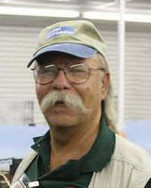

# Page 2

As we wrap up our 2024-2025 season, I’d like to take this opportunity to thank the members of the Fox Valley Division for their continued support and participation. Is this a great hobby or what? I tell folks at the DuPage swap that no other hobby touches as many different aspects as model railroading does. I have found this to be a life-long learning experience that never stops. There is something to learn about just about every day.

Our April clinician was from New Jersey and his presentation over the Zoom computer system about modeling the urban scenes in and around Jersey City and how he adapted a busy commuter terminal plan to apartment living was a great learning opportunity in prototype research, track

planning, urban architecture and train operations. I thought it well done.

Upcoming, we will be at the Glenview Library for our May meeting. Our Clinics and Programs Trainmaster, Gary Saxton, will be explaining his experiments with 3-D printing track. Did we ever think THAT was possible? Another learning opportunity.

Speaking of opportunities: Mr. Osborn needs a back-up person who can assist with equipment set-up for the meetings and Zoom sessions and to fill in when he can’t be Mr. High Technology. Could that be You? Another learning opportunity.

We have decided to make a August 2nd visit to the Illinois Railway Museum with a behind-the-scenes shop tour not done before – the Diesel Shop. Plus, with the CNW and Milwaukee Road Historical Societies having their archives located there, we may get a behind-the-scenes tour of their offices as well. This is a drive-yourself to the Museum and meet up at a specific time event. To cover costs, we will be charging a few $$, which includes the museum entrance and shop tour fees. Details will be forthcoming. Watch the web site and Constant Contact e-mails. IRM hasn’t opened the Diesel Shop to museum attendees before. Another learning opportunity.

Have a great summer. Oh, and if you’re on vacation and take some train or railroad photos, please let us know – you may have the start of a presentation to the group.

Watch for the ‘orange card’ in the mail this summer with the upcoming schedule. You can see the full schedule, clinics and contest topics at:

**h**[**ttps://www.foxvalleydivision.org/fvd2016/timetable.v2.html**](http://www.foxvalleydivision.org/fvd2016/timetable.v2.html)

Always check the Timetable on the website for the latest meeting updates.

**Happenings**: I just learned that Railroad Days at the Pullman Museum will be held May 17 & 18. The event showcases the Pullman National Historical Park, which encompasses 103rd Street to 115th Street, the community, factory site, the official Pullman Historical National Park Service Visitor Center, historic Clock Tower Building and Hotel Florence, among other sites. Restored rail cars will also be on display. Read more about this a complete list of train related activities around the area posted on our website. Check out:

**h**[**ttps://www.foxvalleydivision.org/fvd2016/rrevents.v2.html**](http://www.foxvalleydivision.org/fvd2016/rrevents.v2.html)

I hope everyone has a great summer of train watching and may all your signals be green. Regards, Mike Hirvela, Superintendent

|  |  |  |  |
| --- | --- | --- | --- |
| **The 2024-2025 FVD meeting schedule:** | | | |
| **Date** | **Clinic or Program** | **Model Celebration** | **Time & Location** |
| Sept. 22, 2024 | Car Routing on the CNW Lakeshore Div. by Michael Hirvela | Any Freight Car | 1:30 at the GMC |
| Oct. 20, 2024 | Pulpwood cars by John Drozdak | Any Structure | 1:30 at the GMC |
| Nov. 17, 2024 | Dry Powdered Glue by Eric Petersen, CID | Load spanning 2-3 Cars | 1:30 at the GMC |
| Dec. 15, 2024 | Grand Central Station by Edward Koehler | A Humorous Load | 2:00 at the GPL |
| Jan. 19, 2025 | Other Livestock Operations by Steve Sandifer | Any Vehicle | 2:00 at the GPL |
| Feb. 16, 2025 | Swiss Rail Fanning by Mike Wood | A Train Photo | 2:00 at the GPL |
| Mar. 16, 2025 | Modeling Urban Scenes by Brian Sheron | An Unfinished Project | 2:00 at the GPL |
| Apr. 27, 2025 | The CNJ Newark branch by Jonathan Jones | A Diorama | 2:00 at the GPL |
| May 18, 2025 | Home Manufactured Track by Gary Saxton | Anything about trains | 2:00 at the GPL |
| Aug. 2, 2025 | A Day at the Illinois Railroad Museum - Please read the details of the | visit below. | 10:00 am at IRM |

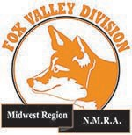Join the Fox Valley Division Of the NMRA

On Our Summer Outing to the

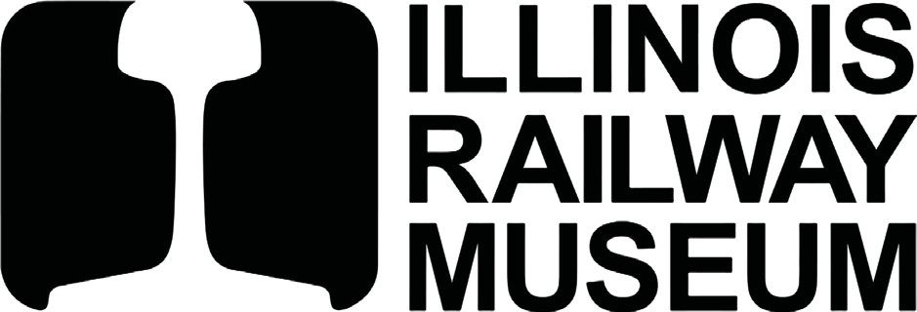

In Union, Illinois For a

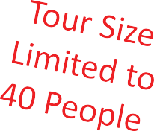**Day at the Museum Private Tour of the Diesel Shop**

**& Historical Society Tours**

Saturday August 2, 2025 See Tentative Schedule Below

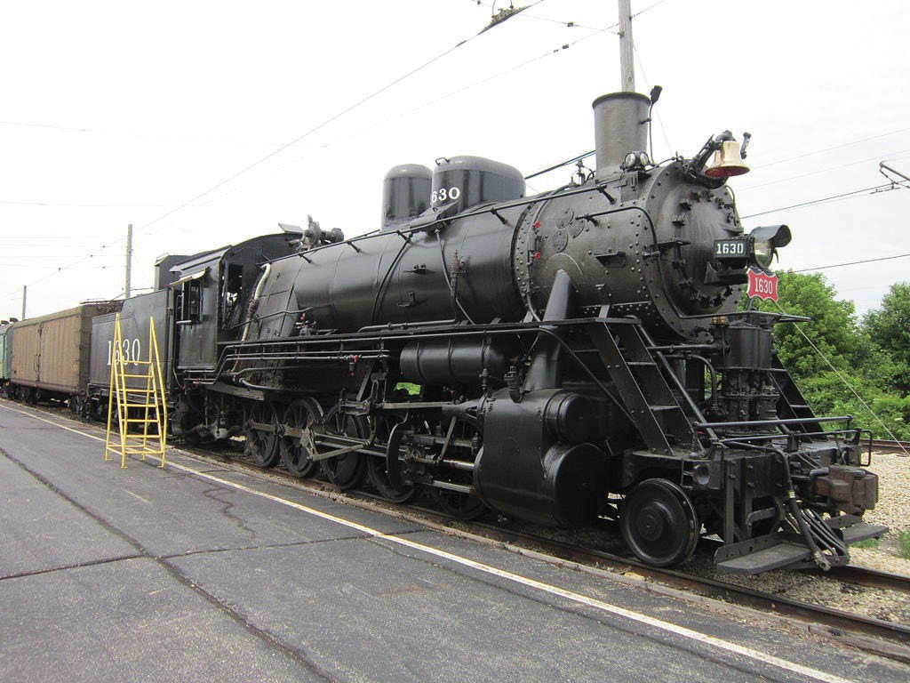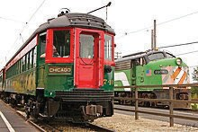

See Operating Equipment, Historical Society Tours And a Behind the Scenes Tour of the Diesel Shop

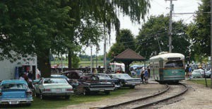**Tentative Schedule for August 2, 2025**

**10 am - IRM Gates Open**

**11 am - Milwaukee Road**

**Historical Assn. Tour 12 pm - Lunch (On Your Own) 1 pm - Diesel Shop Tour 3:30 pm C&NW Historical**

**Society Tour**

**5 pm Optional Local Member Layout Tour in Nearby Woodstock, IL**

**Admission Fees:**

**Regular Fee: $25 per person**

**Includes Museum entrance fee for the day and the tours.**

**IRM Museum Member Fee: $15 per person**

**Includes cost of the tour, but you must have a**

**valid IRM membership to be admitted for this fee.**

**Lunch is on your own (Bring or Buy at IRM)**

**Register Online at the FVD Website:** [***foxvalleydivision.org***](https://www.foxvalleydivision.org/fvd2016/timetable.v2.html)

**See the Timetable Tab on the Website Prepayment is Required as Outlined on the Website**

Fox Valley Division of the National Model Railroad Association For schedule and events see: [*foxvalleydivision.org*](https://www.foxvalleydivision.org/fvd2016/timetable.v2.html)

# Page 5

## A Day at the Illinois Railway Museum with the FVD - A few visit details:

You will need to register and purchase a ticket prior to visiting the facility if you are going to take the exclusive Diesel Shop Tour as well as the CNW and Milwaukee Road archive tours. The deadline for registering and payment is Saturday July 19, 2025.

Guests are welcome but only on a contingent basis if space is not filled up by regular FVD members. If you want to bring a guest, please register and pay for them by the deadline. We will refund any fees for

registrations that cannot be accommodated. We apologize for this limitation on guests participation, but we are restricted to a maximum attendance of 40 people for the tours. We will be moving through an industrial shop environment so please dress accordingly. Open toed shoes and loose fitting garments or wraps

are discouraged. Please provide for your own transportation. There are no bus or car pool arrangements provided by the FVD.

There has been a lot of recent change at the IRM. Here's a link to the IRM website to see all the latest that is available at the museum. **h**[**ttps://www.irm.org/**](http://www.irm.org/)

Maps leading you to the layout tour location after the IRM tours will be provided at the Museum.

The FVD membership asked for extra curricular activities - and we are delivering on that request. Complete the registration form by clicking on the secure link below for a full day of train fun!

## https://form.jotform.com/250974575114966

**Here's a few interesting web links:**

* **This Railroad Could Cripple America's Economy** - A nice video on projects under way on the NE corridor.

**h**[**ttps://www.youtube.com/watch?v=6yLzfNTrULg**](http://www.youtube.com/watch?v=6yLzfNTrULg)

* Abandoned Stationary Steam Engine Brought Back to Life! - 1908 Industrial Time Capsule

**h**[**ttps://www.youtube.com/watch?v=nBImv1mlcMg**](http://www.youtube.com/watch?v=nBImv1mlcMg)

* Ghost Signs: These old faded signs bring a nice touch to old brick structures. Decals of these signs are available from a variety of sources. Here's one:

**h**[**ttps://www.amazon.com/HO-Scale-Waterslide-Realism-Structures/dp/B0BR4BY4W2**](http://www.amazon.com/HO-Scale-Waterslide-Realism-Structures/dp/B0BR4BY4W2)

* Why are rails shaped like they are?

**h**[**ttps://www.youtube.com/watch?v=Nteyw40i9So**](http://www.youtube.com/watch?v=Nteyw40i9So)

* Are you as smart as the train conductor? How do you run around cars when there is no run around? Watch and see how the pros do it. Courtesy of Steve Lanphear, SCWD. **h**[**ttps://www.youtube.com/watch?v=HVKv1AKJKcI**](http://www.youtube.com/watch?v=HVKv1AKJKcI)

FYI, Steve has a regular feed of interesting train info and mystery equipment identification challenges. Interested? Send your email address to Steve with a request to sign-up for regular feeds at: [**scwdmemberlist@mhtc.net**](mailto:scwdmemberlist@mhtc.net)

# Page 6

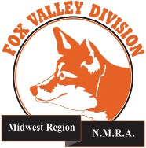

***Semaphore Content and Help Wanted ....***

Interested in keeping the ***Semaphore*** alive? Send us your model or prototype pictures, stories, modeling tips, etc. to share with others in the hobby. **We are also looking for an editor!** Contact any officer with your interest at:

**h**[**ttps://www.foxvalleydivision.org/fvd2016/contactus.v2.html**](http://www.foxvalleydivision.org/fvd2016/contactus.v2.html)

## About the Fox Valley Division

**Superintendent, Mike Hirvela**

**Fox Valley Division Board of Directors**

**Asst. Superintendent, Denis Zamirowski Chief Clerk, Richard Hoker**

**Paymaster, Bob Landwehr**

**Achievements & Contests, Jim Landwehr Clinics & Programs, Gary Saxton**

**Social Media Coordinator, Keith Dart**

**Semaphore Editor, Vacant Ways & Means, Vacant**

**Membership Services, Erich Abens Membership Promotions, Mike Hirvela Web Technologies, Jim Osborn, MMR**® **Public Relations, Keith Dart**

**Need to contact any BoD members? Click this link to:**

**htt**[**ps://www.foxvalleydivision.org/fvd2016/contactus.v2.html**](http://www.foxvalleydivision.org/fvd2016/contactus.v2.html)

**©Copyright 2025 by the Fox Valley Division of the NMRA, Inc.**

If you receive this newsletter, you are an NMRA member & live in the Fox Valley Division area of the Midwest Region and of the National Model Railroad Association (NMRA.) The Fox Valley Division (FVD) includes all of Lake and McHenry, as well as parts of Cook and Kane Counties in northeast Illinois. About 150 members of varied ages and modeling ability levels are in the FVD. Almost all modeling scales are repre- sented in our division. Subscriptions to the Semaphore newsletters are free. NMRA membership is available through the NMRA at:

**htt**[**ps://www.nmra.org/**](http://www.nmra.org/)

2024-2025 FVD monthly meetings are held September through May on-line via the ZOOM virtual meeting technology & at various physical locations per the schedule in this issue. Each meeting features a clinic, modeling celebration of member projects, and infor- mation of interest to the membership. Outings, layout tours, and operating sessions may also be organized.

We encourage you to take advantage of all the FVD has to offer. We are here to answer your questions, help improve your modeling, and help you better enjoy the

great hobby of model railroading. Visit us on the web at:

**htt**[**ps://www.foxvalleydivision.org/**](http://www.foxvalleydivision.org/)

The ***Semaphore*** is published by the Fox Valley Di-

vision of the Midwest Region of the NMRA once a month, ten months a year, from September to June.

The Fox Valley Division of the Midwest Region of the NMRA is registered 501(c)7 not-for-profit Illinois corporation.

## Mailing address:

Fox Valley Division

P. O. Box 1535

Arlington Heights, IL 60005-1535

## Website:

**htt**[**ps://www.foxvalleydivision.org/**](http://www.foxvalleydivision.org/)

Regular meetings are held virtually via Zoom and in person at the Gary Morava Center generally from 1:30 until 4:00 PM per the schedule listed in this publication and on its website at:

**htt**[**ps://www.foxvalleydivision.org/fvd2016/timetable.v2.html**](http://www.foxvalleydivision.org/fvd2016/timetable.v2.html)

Editor: Jim Osborn, MMR® Assistant Editor: Michael Hirvela Assistant Editor: Keith Dart

Follow us on Facebook:

**htt**[**ps://www.facebook.com/fvdnmra/**](http://www.facebook.com/fvdnmra/)