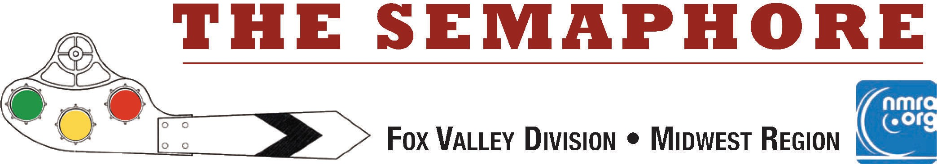

**April 2025**

|  |
| --- |
|  |
| **Several MWR members participated in the O Scale meet in Lombard, IL on March 22, 2025. Above is a picture of one of the many models entered into the model contest. MWR NMRA judges evaluated all the entries. This ACL 17285 ventilated box car by Attalee S. Taylor is one example of the fine model- ing work on display. See additional photos on page 3.** |
| ***In this issue:***  **Page 2: Comments from the FVD Superintendent, Michael Hirvela*.***  **The 2024-2025 FVD meeting schedule.**  **Page 3: Election Candidate Biographies Page 4: FVD Survey Follow-up.**  **"O" Scale meet photos.**  **Page 5: Help wanted.**  **About the Fox Valley Division and the *Semaphore* & FVD Board of Directors.** |
| **Next Division Meet and Annual Business meeting - April 27, 2025 at the Glenview Public Library - 2:00 start: Clinic Presentation: The CNJ Newark Branch** by Jonathan Jones - Jonathan brings his architectural training and outlook to urban layout design. Jonathan models the Newark branch of the Central Railroad of New Jersey in his Brooklyn, NY apartment. He will highlight aspects of the CNJ and the gritty dense industrial urban right-of-way that captured his interest. His modeling is a combination of traditional realistic representation and abstraction. |

# Mike's Minute ...

Folks who attended the March member meeting at the Glenview Public Library were looking forward to a day closer to Spring and what did Mom Nature bring forth? Snow! Enough of it to cause second thoughts regarding being present. But that is what Zoom is for. Or is it? Sure enough, as we assembled the equipment for the meeting, we noted we were getting reports folks trying to log-on to the system were getting error reports on their screens. We’re not sure what happened, but Mr. Osborn was able to get the situation rectified just in time to get the show started. This also brings up a volunteer opportunity. Mr. Osborn needs a back-up person who can assist with equipment set-up and to fill in when he can’t. Could that be You? Let us know.

We will be at the Glenview Library for our April meeting. Per the By-Laws, the Annual Meeting of the Members is held in April and will include reports from the board members and election of two officers for the upcoming two-year terms for Assistant Superintendent and Paymaster. Then on with the regular meeting stuff. So, join us and see what’s going on in the division. The May meeting will also be at the Glenview Public Library to wrap up our 2024-2025 season. The 2025-2026 season starts September 21st somewhere.

We’ve been discussing a summer outing. The board has agreed on a visit to the **Illinois Railway Museum** with a behind- the-scenes diesel shop tour not done before. Plus, with the CNW and Milwaukee Road Historical Societies having their archives located there, we may get a behind-the-scenes tour as well. We are also planning on a **layout tours** in July. Details to follow. Stay tuned.

As we wrap up our 2025 season schedule, I want to thank each and every member for their participation and support, no matter how you choose to contribute. I appreciate this more than you know.

You can see the full schedule, clinics and contest topics below, or at:

**h**[**ttps://www.foxvalleydivision.org/fvd2016/timetable.v2.html**](http://www.foxvalleydivision.org/fvd2016/timetable.v2.html)

Always check the Timetable on the website for the latest meeting updates.

**Happenings**: You can see a complete list of train related activities around the area posted on our website. Check out:

**h**[**ttps://www.foxvalleydivision.org/fvd2016/rrevents.v2.html**](http://www.foxvalleydivision.org/fvd2016/rrevents.v2.html)

I just read an announcement from the folks doing the restoration on CNW #1385. There will be an over-the-road transit of the loco May 7 - 9. They state the trip will be live-streamed with details available as the day gets closer. Here's a Link to their latest announcement. **h**[**ttps://www.foxvalleydivision.org/fvd2016/imagesfvd2016/events/cnw1385may2025.pdf**](http://www.foxvalleydivision.org/fvd2016/imagesfvd2016/events/cnw1385may2025.pdf)

**Summer Activities:** We’re already working on summer outings. Lots of ideas. Got one? Let me know.

As we continue through our early 2025 schedule, I want to thank each and every member for their participation and support, no matter how you choose to contribute. I appreciate this more than you know. Planning has already started on the later half of 2025 and into 2026.

I hope everyone has a great summer of train watching. Regards, Mike Hirvela, Superintendent

|  |  |  |  |
| --- | --- | --- | --- |
| **The 2024-2025 FVD meeting schedule:** | | | |
| **Date** | **Clinic or Program** | **Model Celebration** | **Time & Location** |
| Sept. 22, 2024 | Car Routing on the CNW Lakeshore Div. by Michael Hirvela | Any Freight Car | 1:30 at the GMC |
| Oct. 20, 2024 | Pulpwood cars by John Drozdak | Any Structure | 1:30 at the GMC |
| Nov. 17, 2024 | Dry Powdered Glue by Eric Petersen, CID | Load spanning 2-3 Cars | 1:30 at the GMC |
| Dec. 15, 2024 | Grand Central Station by Edward Koehler | A Humorous Load | 2:00 at the GPL |
| Jan. 19, 2025 | Other Livestock Operations by Steve Sandifer | Any Vehicle | 2:00 at the GPL |
| Feb. 16, 2025 | Swiss Rail Fanning by Mike Wood | A Train Photo | 2:00 at the GPL |
| Mar. 16, 2025 | Modeling Urban Scenes by Brian Sheron | An Unfinished Project | 2:00 at the GPL |
| Apr. 27, 2025 | The CNJ Newark branch by Jonathan Jones | A Diorama | 2:00 at the GPL |
| May 18, 2025 | Home Manufactured Track by Gary Saxton | Anything about trains | 2:00 at the GPL |
| Aug. 2, 2025 A Day at the Illinois Railroad Museum - Tentative date - details will be forth-coming | | | |

## Candidate Biographies for the April 27th Election of Officers

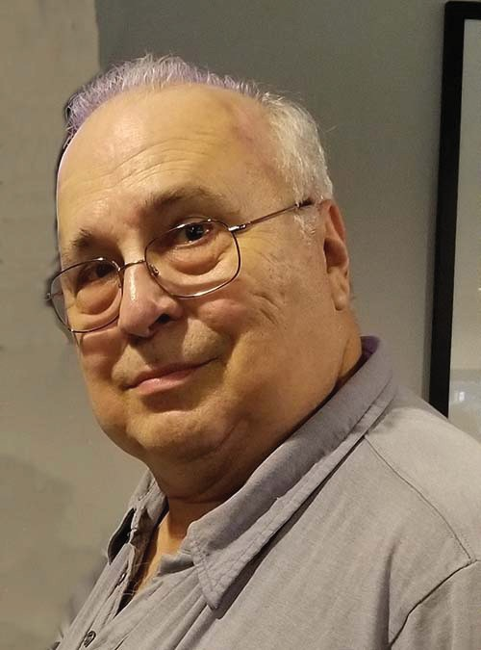**Denis Zamirowski for Assistant Superintendent (Incumbent)**

I became interested in trains when I was about four years old and went with my family to the 1949 Railroad Fair on the Chicago lakefront. I guess the size and mechanisms of these huge locomotives would fas- cinate any four year old. My first train set was American Flyer. Later on, I was intrigued by my Uncle’s layout and the big layout at the Museum of Science and Industry and decided to build my own. I sent away and bought and built a Mantua locomotive kit at about age fourteen (it still runs).

I joined the NMRA over 25 years ago and became involved in the old North Shore and Western Division and then the Fox Valley Division after the merger. I have been a volunteer for many High Wheeler shows,

an I-Hobby Show, the Midwest Region Convention in Schaumburg and the Fox Valley Division since Bob Schlemon moved away. I serve as proxy for our Superintendent at Midwest Region meetings. I also pick up refreshments for our Division meetings. I hope to serve effectively for another term.

## Bob Landwehr for Paymaster (Incumbent)

Hi – My name is Bob Landwehr and I'm running for FVD Paymaster. I have been in love with model railroading ever since I was a child and have been an active NMRA member since 2011.

I served as a Midwest Region Director-at-large from 2016 – 2020 and I’m currently filling the remaining paymaster term after Rich Sieban's resignation. I am also transitioning to be come the next Membership Chairman of the Midwest Region commensurate with Ron Scharpings’s retirement from that position. I also have a bachelors degree in com- puter science from Northern Illinois University and an AS degree in electronics from Harper college. In my spare time I work with my broth-

er Jim building his club size HO layout (2-3 level 60’ x 20’) that has an 8-foot-long walk under bridge (72 inches above the floor). I would appreciate your support and vote for the position.

## Election details:

The voting for this election will occur during the April 27th FVD Annual Business meeting. The meeting will be held at the Glenview Public Library in the Multi-Purpose room of the library at 2:00 pm. Remote access to the meeting will be via the Zoom application. Log-in credentials will be sent out about 1 week prior to the meeting. Please update your Zoom application prior to the meeting. There have been several important updates to the application.

## FVD Survey follow-up:

You spoke and we listened. There was a request for more activities. We are planning an **IRM group tour on August 2nd** and a couple of **layout tours in July**. The details are being flushed out and will be available soon.

**Please let us hear your additional thoughts! Email us at:** [**mwr.nmra.webmaster@gmail.com**](mailto:mwr.nmra.webmaster@gmail.com)

## March "O" Scale meet in Lombard:

Jim Landwehr (FVD), Jim Osborn (FVD), Steve Miazga (WISE) and Rusty Dramm (DuPage) judged contest models at the meet. The entries were all very well done. Here are a few pictures of what was on display. You can see photos of all the models on the Model Photo Album web page of the Midwest Region Website: **h**[**ttps://www.mwr-nmra.org/**](http://www.mwr-nmra.org/)

Left column Captions - Top to Bottom: Right Column Captions - Top to Bottom:

* Palmer Machinery Scene by Gregory Cygna - CNW 7201 Parlor Observation by Ed Wicham
* Burlington 9811 Gas Electric by Ralph L. Nelson - FRV 2401 SD24 by Shaydin Anthony
* IC 15474 Mini Hy Cube Box Car by Ken Kim - C&O Greenbriar 611 by Bruce J. Aikman

- Greenline Street Car by Marc Knoll

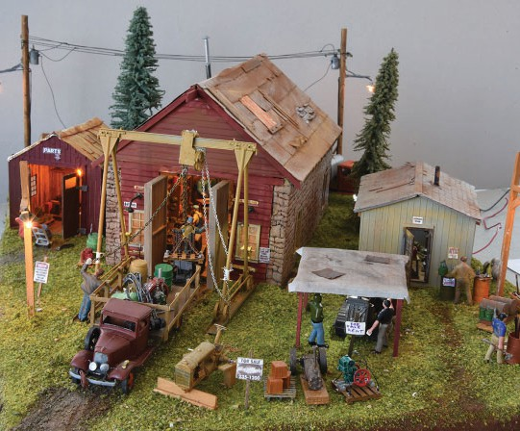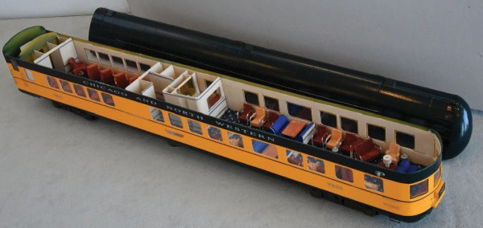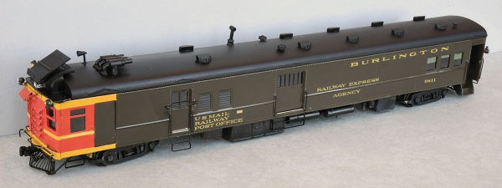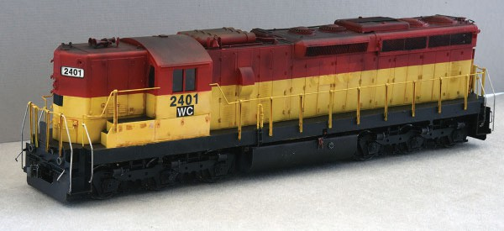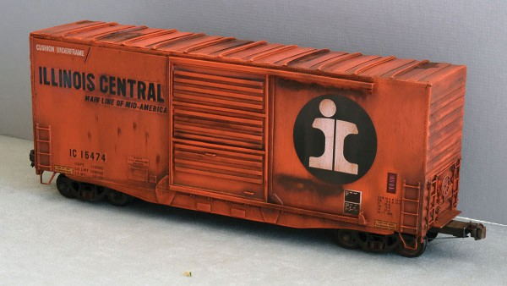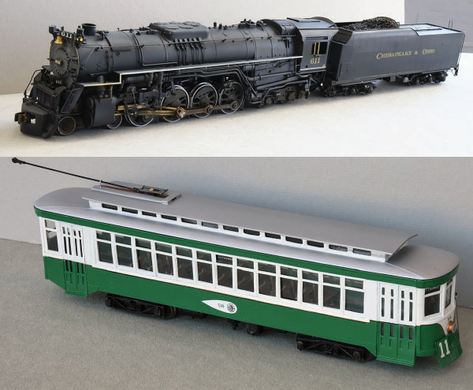

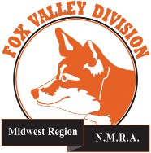

***Semaphore Content and Help Wanted ....***

Interested in keeping the ***Semaphore*** alive? Send us your model or prototype pictures, stories, modeling tips, etc. to share with others in the hobby. **We are also looking for an editor!** Contact any officer with your interest at:

**h**[**ttps://www.foxvalleydivision.org/fvd2016/contactus.v2.html**](http://www.foxvalleydivision.org/fvd2016/contactus.v2.html)

## About the Fox Valley Division

**Superintendent, Mike Hirvela**

**Fox Valley Division Board of Directors**

**Asst. Superintendent, Denis Zamirowski Chief Clerk, Richard Hoker**

**Paymaster, Bob Landwehr**

**Achievements & Contests, Jim Landwehr Clinics & Programs, Gary Saxton**

**Social Media Coordinator, Keith Dart**

**Semaphore Editor, Vacant Ways & Means, Vacant**

**Membership Services, Erich Abens Membership Promotions, Mike Hirvela Web Technologies, Jim Osborn, MMR**® **Public Relations, Keith Dart**

**Need to contact any BoD members? Click this link to:**

**htt**[**ps://www.foxvalleydivision.org/fvd2016/contactus.v2.html**](http://www.foxvalleydivision.org/fvd2016/contactus.v2.html)

**©Copyright 2025 by the Fox Valley Division of the NMRA, Inc.**

If you receive this newsletter, you are an NMRA member & live in the Fox Valley Division area of the Midwest Region and of the National Model Railroad Association (NMRA.) The Fox Valley Division (FVD) includes all of Lake and McHenry, as well as parts of Cook and Kane Counties in northeast Illinois. About 150 members of varied ages and modeling ability levels are in the FVD. Almost all modeling scales are repre- sented in our division. Subscriptions to the Semaphore newsletters are free. NMRA membership is available through the NMRA at:

**htt**[**ps://www.nmra.org/**](http://www.nmra.org/)

2024-2025 FVD monthly meetings are held September through May on-line via the ZOOM virtual meeting technology & at various physical locations per the schedule in this issue. Each meeting features a clinic, modeling celebration of member projects, and infor- mation of interest to the membership. Outings, layout tours, and operating sessions may also be organized.

We encourage you to take advantage of all the FVD has to offer. We are here to answer your questions, help improve your modeling, and help you better enjoy the

great hobby of model railroading. Visit us on the web at:

**htt**[**ps://www.foxvalleydivision.org/**](http://www.foxvalleydivision.org/)

The ***Semaphore*** is published by the Fox Valley Di- vision of the Midwest Region of the NMRA once a month, ten months a year, from September to June.

The Fox Valley Division of the Midwest Region of the NMRA is registered 501(c)7 not-for-profit Illinois corporation.

## Mailing address:

Fox Valley Division

P. O. Box 1535

Arlington Heights, IL 60005-1535

## Website:

**htt**[**ps://www.foxvalleydivision.org/**](http://www.foxvalleydivision.org/)

Regular meetings are held virtually via Zoom and in person at the Gary Morava Center generally from 1:30 until 4:00 PM per the schedule listed in this publication and on its website at:

**htt**[**ps://www.foxvalleydivision.org/fvd2016/timetable.v2.html**](http://www.foxvalleydivision.org/fvd2016/timetable.v2.html)

Editor: Jim Osborn, MMR® Assistant Editor: Michael Hirvela Assistant Editor: Keith Dart

Follow us on Facebook:

**htt**[**ps://www.facebook.com/fvdnmra/**](http://www.facebook.com/fvdnmra/)