MONTHLY NEWSLETTER OF THE FOX VALLEY DIVISION, NMRA

The Semaphore

**In this issue**

O C T O B E R 2 0 2 4

**Mike’s Minute P.1 Next FVD Meeting P.2 Upcoming Events P.3 Model Calendar P.4 About FVD P.4**

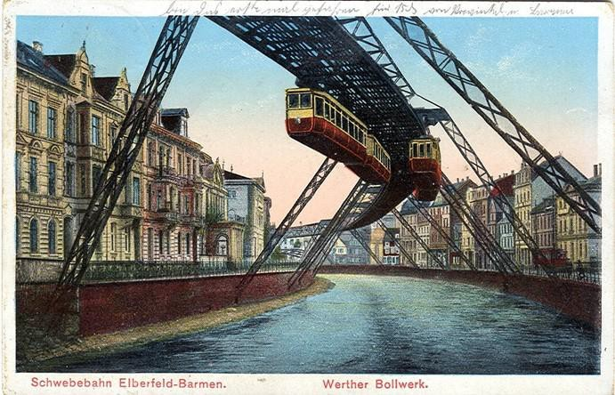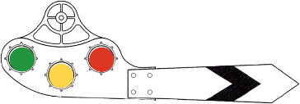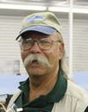

**But doesn’t the blood rush to your head?**

Looks like it’s upside down, but the Wuppertaler Schwebebahn (Wuppertal Suspension Railway) in Germany has been running this way since 1901. 1913 postcard by Anonymous - private collection of Wolfgang Sauber (Xenophon), Public Domain, [Wikimedia](https://commons.wikimedia.org/w/index.php?curid=4832857)

Our 2024-2025 season started last month at the Morava Recreation Center in Prospect Heights and will continue to be there for the next several meetings. The next meeting is October 20. As much as we’d like to see you in person and we encourage you to be (because we had some wonderful snacks available), we do have arrangements for meeting participation over Zoom.

Whichever method (in person or over the net) you select to participate, I appreciate you taking the time and effort to attend and contribute. The schedule for our 2024-2025 season is out on the “Orange Card. Some clinic topics are listed as To Be Announced (TBA). Some topics and presenters just

Mike’s Minute

weren’t nailed down by the deadline for the card printing. There are several topics our Clinics and Programs guy, Gary Saxton, is pursuing. We will put the updated information on our website and Facebook page as soon as solid topics and dates can be arranged.

Going along with the thought of clinics, Rich Mahaney, of North Central Region, has asked the MWR and divisions to help locate members who have presented topics recently, and would be willing to be presenters at the 2025 NMRA National Convention in Novi, Michigan. Info will be in the Semaphore newsletter. This is something to consider as it will provide national exposure to your topic.

**1**

Mike’s Minute, continued

As I noted at our September meeting, Chris Mattimiro has informed us he intends to relinquish the position of Newsletter Editor soon. So, if you think you have what it takes to do our newsletter, please let him or me know. Chris has done a wonderful job on the last several issues and he will be a tough act to follow, but here’s your opportunity to shine. Additionally, there are Achievement Program points for this service. You don’t have to be an expert, just have an interest and volunteer yourself. Chris will confirm it is rewarding.

Lastly, there were a LOT of folks trackside for the CPKC #2816 and the UP #4014 steam locomotives as they traveled the country this past summer, and a lot of pixels were filled in digital cameras. Were you one of those lucky folks? I’d encourage you to contact Gary and let’s set up a slide show to let the rest of us know what we missed. You’ll be glad you did.

*- Mike Hirvela*

Next FVD Meeting

**When:** Sunday, October 20, 2024, 1:30 PM

**Where:** [Gary Morava Recreation Center, Prospect Heights](https://maps.app.goo.gl/aQYkKagCAokySG16A) and [Zoom](https://zoom.us/)

**Presentation:** *Pulpwood Cars* by John Drozdak, FVD

John will present an up-front and personal understanding of pulpwood cars and how to construct them.

**Model Achievement Display:** Any interesting structure of your choice

**Join Zoom:** [**https://us02web.zoom.us/j/87376124919?pwd=CaUhbq1DTRNZQUwbykfW206aLx3Haf.1**](https://na01.safelinks.protection.outlook.com/?url=https%3A%2F%2F4hkwpoeab.cc.rs6.net%2Ftn.jsp%3Ff%3D001JaNxe4U8Fi8KrugUqXee7XcY-JjOOVGwCq64Pbq_UK5Doz4B335vEluHOGhgbLduu_GH5w-eDL8s7VBmt82v7gBlcZFpbdsbxC9GNanirsHxrr6B6fN4ZR0Po5lNIk7qzsHcLnXCJa_WqHQK29MrveW5MtIgpGKIoTQpLwkmCRfz0nMpMtEUq1ZlAFVBV0NLYPpAhrSqn6SE5Inoy-a0zhZYumJmECBQ%26c%3Dv0CeUoWjxTqDfXpCAxN92tUG7rmVg2q7bTjBTiRJnO_r0RJ-us51aw%3D%3D%26ch%3DFiaBz_IMI3MXH4ENgkltoH2W37d-U9Y0t2LW0i7untWlAcZ8t0rq2w%3D%3D&data=05%7C02%7C%7C438a595071274284c96408dcec7e4950%7C84df9e7fe9f640afb435aaaaaaaaaaaa%7C1%7C0%7C638645274354874847%7CUnknown%7CTWFpbGZsb3d8eyJWIjoiMC4wLjAwMDAiLCJQIjoiV2luMzIiLCJBTiI6Ik1haWwiLCJXVCI6Mn0%3D%7C0%7C%7C%7C&sdata=3QdD4rGbqPcVe5ITRXj9qPliKgtoOhaz0QnWp3gbaCM%3D&reserved=0)

**Meeting ID:** 873 7612 4919

**Passcode:** 637554

**got trains?**

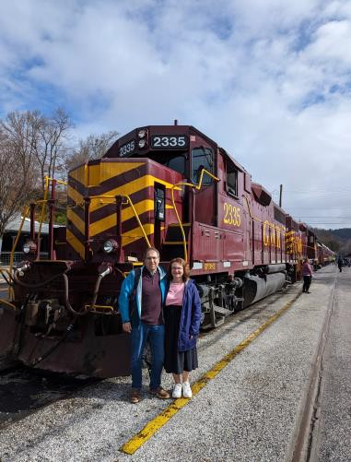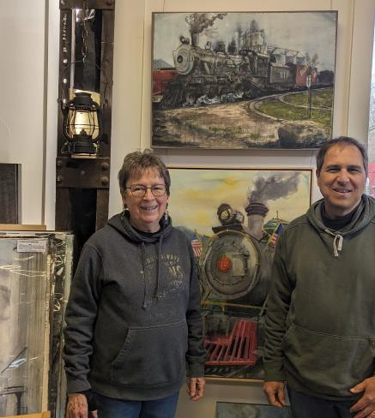

**Riding one, running a model, laying track, assembling scale structures, debugging hardware/software, looking at art, visiting a museum, just thinking about them? Got an interesting story to tell? We're story spotters, looking for people to share their experience (or lack thereof)! Contact Chris Mattimiro,** [**cmattimiro@outlook.com**](mailto:cmattimiro@outlook.com)**.**

**2**



Upcoming Events

* **Monthly FVD Meetings**

Held the third Sunday of every month at either the [Glenview Public Library](https://glenviewpl.org/) or the [Gary Morava Recreation Center](https://phparks.org/location/gary-morava-recreation-center/), the meetings are an opportunity to share information, either in-person or on Zoom. Here is the meeting schedule through the end of the year. See the full schedule on the [FVD website](https://foxvalleydivision.org/fvd2016/timetable.v2.html).

|  |  |
| --- | --- |
| **When** | **Where** |
| 10/20/24 1:30 PM | Gary Morava Recreation Center & [Zoom](https://zoom.us/) |
| 11/17/24 1:30 PM |
| 12/15/24 1:30 PM |

* **Club Events & Shows** (click links for more information)

[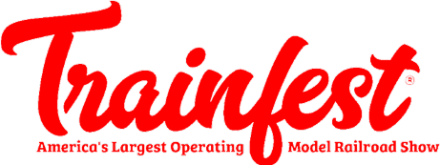](https://www.train-fest.com/)

November 23-24, 9 AM – 5 PM. Baird Center, 400 W Wisconsin Ave, Milwaukee WI. 170,000 square feet of model trains! [**Trainfest Information**](https://www.train-fest.com/)

[East Troy Electric Railroad Harvest Fest](https://www.easttroyrr.org/harvest-fest.html) Weekends through October 27. Combine the fun of a ride on a historic electric train with fall activities.

[Great Midwest Train Shows](https://www.trainshow.com/) are held monthly at the [DuPage Event Center and](https://dupagecountyfair.org/dupage-county-fair/#general) [Fairgrounds](https://dupagecountyfair.org/dupage-county-fair/#general) in Wheaton. Information on both shows can be found on [Trainshow.com](https://www.trainshow.com/).

[Illinois Railway Museum Events](https://www.irm.org/) in September. Follow links below for more information.

* + [Pumpkin Train](https://www.irm.org/event/pumpkin-train/?event_date=2024-10-26), October 19-20 and 26-27. Enjoy a ride to IRM’s pumpkin patch aboard Halloween-themed electric interurban trains.
  + [Happy Holiday Railway](https://www.irm.org/event/happy-holiday-railway/?event_date=2024-12-22), Weekends starting November 29 through December 22. Embark on a magical 40-minute train ride through the winter countryside with Santa Claus himself!

[Lake County Model Railroad Open House](https://lcmrr.org/) November 2 & 3, 11AM – 4 PM. 107 S Main St, Wauconda, IL. Under Honey Hill Coffee Shop.

[Chicago & North Western Historical Society](https://www.facebook.com/cnwhs) 15th Chicago Area Get Together, Saturday, November 16, 2024, 3 pm to 8 pm, at Normandy Banquets located at the American Legion Hall, 210 West Butterfield Road, Elmhurst, IL. $48 per person.

|  |  |  |  |  |  |  |
| --- | --- | --- | --- | --- | --- | --- |
|  | | | | | | |
| Model Celebration Calendar | | | | | | |
|  | | | | | | |
|  | | **Division Meeting Date Contest** | | | |  |
| October 20 Any structure | | | |  |
| November 17 One load spanning 2 or 3 cars | | | |
| December 15 A humorous load | | | |
| January 19 Any vehicle | | | |
| February 16 Any train photo | | | |
| March 16 An unfinished project | | | |
|  | |  | | | |  |
|  | | | | | | |
|  | About the Fox Valley Division  **Board of Directors**  About the Semaphore  **Superintendent**: Michael Hirvela **Membership Promotions**: Michael  **Asst. Superintendent**: Denis Hirvela The Semaphore is published by the Zamirowski **Membership Services**: Erich Abens Fox Valley Division of the Midwest  **Paymaster**: Bob Landwehr **Public Relations & Social Media**: Region of the NMRA, a registered  **Chief Clerk**: Richard Hoker Keith Dart 501(c)(7) not-for-profit Illinois  **Achievements & Contests**: Jim **Webmaster**: Jim Osborn, MMR®  Landwehr **Semaphore Editor**: Chris Mattimiro corporation.  **Clinics & Programs**: Gary Saxton **Staff**:  Contact any board member [here](http://www.foxvalleydivision.org/fvd2016/contactus.v2.html). Editor: Chris Mattimiro  Assistant Editor: Michael Hirvela | | | | | |
|  | If you receive this newsletter you live in the Midwest Region, Fox Valley Division of the National Model Railroad Association (NMRA). The Fox Valley Division (FVD) includes all of Lake and McHenry, as well as parts of Cook and Kane Counties in northeast Illinois. About 180 members of varied ages and modeling ability belong to the FVD. Most modeling scales are represented in our division.  Subscriptions to the Semaphore newsletters are free. Membership in the division is available through the NMRA at: <https://www.nmra.org/>  Monthly FVD meetings run September through May in-person and online via [Zoom.](https://zoom.us/) Each meeting features a clinic, model show, and | |  | information of interest to the membership. Outings, layout tours, and operating sessions may also be held.  We encourage you to take advantage of all the FVD has to offer. We are here to answer your questions, help improve your modeling, and help you better enjoy the great hobby of model railroading. Visit us on the [web](https://foxvalleydivision.org/)!  **Mailing Address:**  Fox Valley Division PO Box 1535  Arlington Heights IL 60005-1535  **Website**:  <https://foxvalleydivision.org/>  **Facebook:**  <https://www.facebook.com/fvdnmra/> | Assistant Editor: Jim Osborn  © 2024 by the Fox Valley Division of the NMRA, Inc. | |
|  |  |



6

**3**