MONTHLY NEWSLETTER OF THE FOX VALLEY DIVISION, NMRA

**The Semaphore**

S E P T E M B E R 2 0 2 4

**In this issue**

**Mike’s Minute P.1 Next FVD Meeting P.2 Upcoming Events P.3 Contest Calendar P.4**

**About FVD P.4**

# Big Boy Comes to Chicago

A view of #4104 on the Indiana Harbor Belt Railway in Chicago Ridge, near the Wabash (Metra Southwest) crossing. Photo: Gary Rhebergen

Welcome back to another season of great railroad modeling and the camaraderie of friendship that is our National Model Railroad Association. It was a busy summer for some of us, which includes a visit from the UP #4014 and summer excursions to other exotic cities. If you were trackside for any railroad – related event, I hope you took your still or video camera and recorded some memories. Our Semaphore Newsletter Editor, Chris Mattimiro, is looking for photos with captions of your summer activities. As a

matter of fact, as I write this, I (along with MMR Jim Allen) am in Pittsburgh,

Mike’s Minute

PA, at the National Narrow-Gauge Convention, having a good time meeting old friends and making new ones. There are some BIG hobby names here,

and some *really* excellent modeling, in many scales. I hope to add photos of some of the models we saw at the next division meet. Speaking of which: Our 2024-2025 season gets started on September 22nd at the Morava Center in Prospect Heights and will continue to be there for

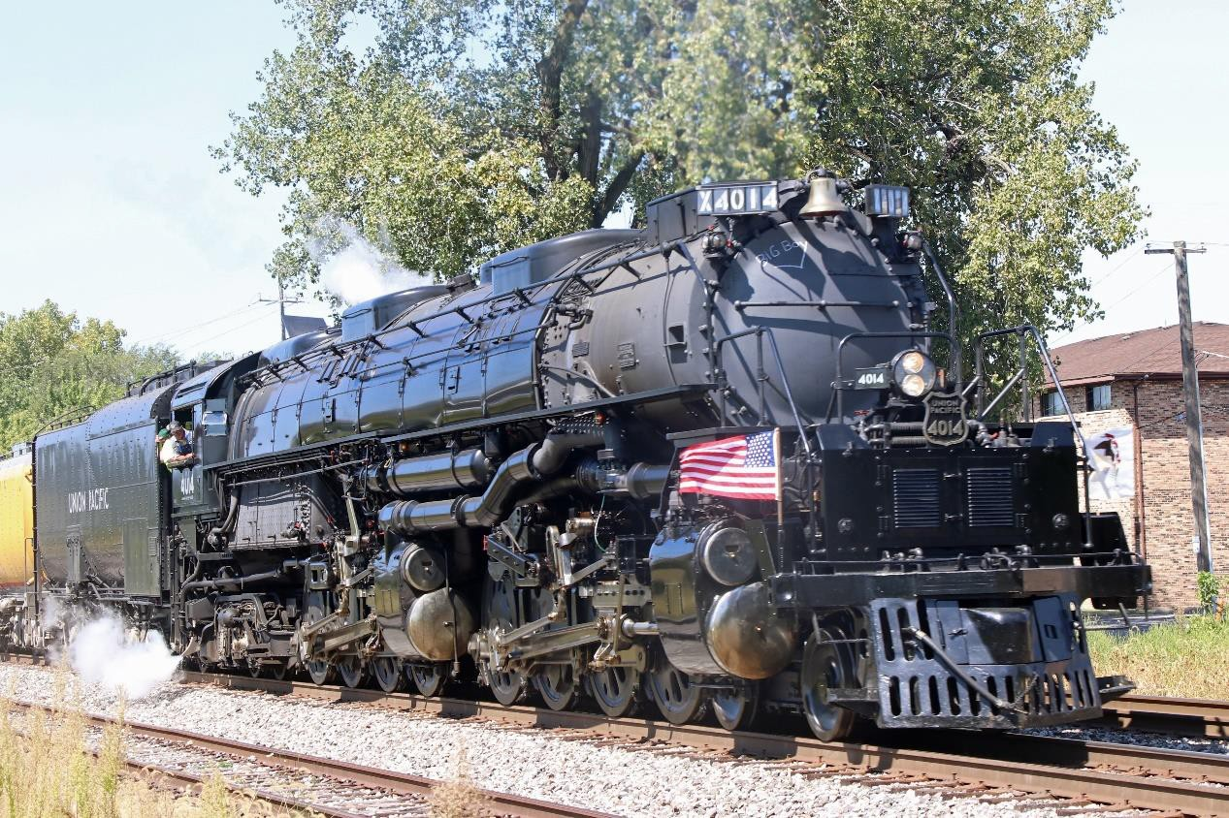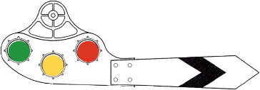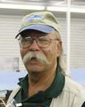

several meetings. As much as we’d like to see you in person, we do have arrangements for meeting participation over Zoom. Whichever method (in person or over the net) you select to participate, I appreciate you taking the time and effort to attend and contribute. The schedule for our 2024-2025 season is out on the “Orange Card,” which you should have in hand by now. Now, when you get it, you’ll notice some topics listed as TBA (to be announced). Some things just aren’t nailed down by the deadline for the card printing.

**1**

Mike’s Minute, continued

We will put information on our website and Facebook page as soon as solid topics and dates can be arranged.

Lastly, Chris Mattimiro has informed us he intends to relinquish the position of Newsletter Editor soon. So, if you think you have what it takes to do our newsletter, please let him or me know.

Chris has done a wonderful job on the last several issues and he will be a tough act to follow, but here’s your opportunity to shine. Additionally, there are Achievement Program points for this service.

Well, I hope wherever you went this past summer, you found the train-chasing as rewarding and thrilling as the new season’s interesting and informative presentations will be. We’re continually trying.

*- Mike Hirvela*

Next FVD Meeting

**When:** Sunday, September 22, 2024, 1:30 PM

**Where:** [Gary Morava Recreation Center, Prospect Heights](https://maps.app.goo.gl/aQYkKagCAokySG16A) and [Zoom](https://zoom.us/)

**Presentation:** *Car Routing on the C&NW* by Michael Hirvela

Mike will explain realistic ways freight cars are routed on his model railroad.

**Model Achievement Display:** Any freight car

**Join Zoom:** <https://us02web.zoom.us/j/87012255330?pwd=WsXciFctnafvtwN63Y8uoVAQfdlVnD.1>

**Meeting ID:** 870 1225 5330

**Passcode:** 530411

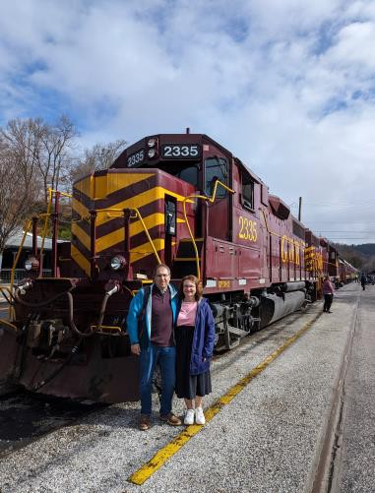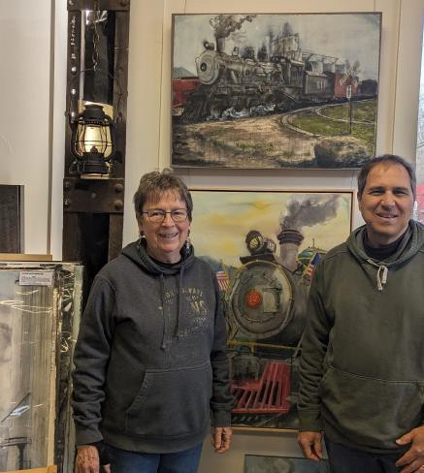

**got trains?**

**Riding one, running a model, laying track, assembling scale structures, debugging hardware/software, looking at art, visiting a museum, just thinking about them? Got an interesting story to tell? We're story spotters, looking for people to share their experience (or lack thereof)! Contact Chris Mattimiro,** [**cmattimiro@outlook.com**](mailto:cmattimiro@outlook.com)**.**

**2**



Upcoming Events

## Monthly FVD Meetings

Held the third Sunday of every month at either the [Glenview Public Library](https://glenviewpl.org/) or the [Gary Morava Recreation Center](https://phparks.org/location/gary-morava-recreation-center/), the meetings are an opportunity to share information, either in-person or on Zoom. Here is the meeting schedule through the end of the year. See the full schedule on the [FVD website](https://foxvalleydivision.org/fvd2016/timetable.v2.html).

|  |  |
| --- | --- |
| **When** | **Where** |
| 9/22/24 1:30 PM | Gary Morava Recreation Center & [Zoom](https://zoom.us/) |
| 10/20/24 1:30 PM |
| 11/17/24 1:30 PM |
| 12/15/24 1:30 PM |

* **Club Events & Shows** (click links for more information)

[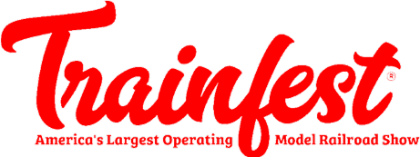](https://www.train-fest.com/)

November 23-24, 9 AM – 5 PM. Baird Center, 400 W Wisconsin Ave, Milwaukee WI. 170,000 square feet of model trains! [**Trainfest Information**](https://www.train-fest.com/)

[HO Scale Model Railroad Equipment Sale](mailto:nwpoca@hotmail.com) September 21. 7761 W. Peterson Ave, Chicago, IL. Grab some bargains from the closing of a 2500 sq. ft. premier Chicago area operating layout.

[Great Midwest Train Shows](https://www.trainshow.com/) are held monthly at the [DuPage Event Center and](https://dupagecountyfair.org/dupage-county-fair/#general) [Fairgrounds](https://dupagecountyfair.org/dupage-county-fair/#general) in Wheaton. Information on both shows can be found on [Trainshow.com](https://www.trainshow.com/).

[Illinois Railway Museum Events](https://www.irm.org/) in September. Follow links below for more information.

* + [Showcase Weekend](https://www.irm.org/event/museum-showcase-weekend/?event_date=2024-09-15), Saturday, September 14 & 15. See and ride some of the less frequently run equipment at IRM
  + [Steam Into Fall](https://www.irm.org/event/steam-in-the-fall/?event_date=2024-10-05), Saturday, October 5. Enjoy the fall colors of bucolic McHenry County from the window of a 100-year-old steam train!
  + [Pumpkin Train](https://www.irm.org/event/pumpkin-train/?event_date=2024-10-26), October 19-20 and 26-27. Enjoy a ride to IRM’s pumpkin patch aboard Halloween-themed electric interurban trains.

[Chicagoland Railroad Prototype Modelers (RPM) Conference](https://www.rpmconference.com/), October 10 – 12, 2024, at NIU, 1120 Diehl Road, Naperville. FVD is co-sponsoring the event.

**3**

Contest Calendar

6

# Contest rules

|  |  |
| --- | --- |
| **Division Meeting Date** | **Contest** |
| September 22 | Any freight car |
| October 20 | Any structure |
| November 17 | One load spanning 2 or 3 cars |
| December 15 | A humorous load |

Contests be held in person at the meet. There will be no photographic entries. All entries will ONLY be displayed at the meet.

About the Fox Valley Division **Board of Directors Superintendent**: Michael Hirvela



**Asst. Superintendent**: Denis

Zamirowski **Paymaster**: Bob Landwehr **Chief Clerk**: Richard Hoker **Achievements & Contests**: Jim

Landwehr

**Clinics & Programs**: Gary Saxton

If you receive this newsletter you live in the Midwest Region, Fox Valley Division of the National Model Railroad Association (NMRA). The Fox Valley Division (FVD) includes all of Lake and McHenry, as well as parts of Cook and Kane Counties in northeast Illinois. About 180 members of varied ages and modeling ability belong to the FVD. Most modeling scales are represented in our division.

Subscriptions to the Semaphore newsletters are free. Membership in the division is available through the NMRA at: <https://www.nmra.org/>

Monthly FVD meetings run September through May in-person and online via [Zoom.](https://zoom.us/) Each meeting features a clinic, model contest, and

**Membership Promotions**: Michael Hirvela

**Membership Services**: Erich Abens

**Public Relations & Social Media**: Keith Dart

**Webmaster**: Jim Osborn, MMR®

**Semaphore Editor**: Chris Mattimiro Contact any board member [here](http://www.foxvalleydivision.org/fvd2016/contactus.v2.html).

information of interest to the membership. Outings, layout tours, and operating sessions may also be held.

We encourage you to take advantage of all the FVD has to offer. We are here to answer your questions, help improve your modeling, and help you better enjoy the great hobby of model railroading. Visit us on the [web](https://foxvalleydivision.org/)!

### Mailing Address:

Fox Valley Division PO Box 1535

Arlington Heights IL 60005-1535

### Website:

<https://foxvalleydivision.org/>

### Facebook:

<https://www.facebook.com/fvdnmra/>

About the Semaphore

The Semaphore is published by the Fox Valley Division of the Midwest Region of the NMRA, a registered 501(c)(7) not-for-profit Illinois corporation.

## Staff:

Editor: Chris Mattimiro Assistant Editor: Michael Hirvela Assistant Editor: Jim Osborn

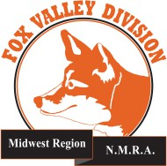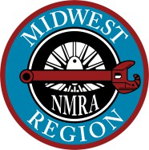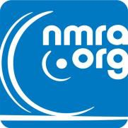

© 2024 by the Fox Valley Division of the NMRA, Inc.