MONTHLY NEWSLETTER OF THE FOX VALLEY DIVISION, NMRA

A U G U S T 202 4

The Semaphore

**Wheel**

**Boneyard at**

**the Great Train Story**

Where spent wheelsets fade away

# Big Boy in

Keep ‘em Running

**In this issue**

MSI Visit Big Boy’s Coming! Event Calendar Contact Info

# Illinois

Big Boy 4014 will be on display to the public on Sunday, September 8 in Rochelle, IL. Specific location and time have not yet been announced. Check back with the [Rochelle website](https://www.cityofrochelle.net/union-pacifics-big-boy-4014-steam-engine-to-visit-rochelle/) for updates.

# Behind the scenes at Griffin Museum of Science & Industry in Chicago

*B y C h r i s M a t t i m i r o . P h ot o s b y R i c h a r d H o k e r*

Fox Valley Division members, friends and family recently visited the Griffin Museum of Science and Industry (MSI) in Chicago for a behind-the- scenes look at two exhibits close to our hearts: the Pioneer Zephyr and The Great Train Story.

The Zephyr exhibit, at MSI since 1960 was recently renovated with multimedia displays, improved access and interactive stations. Exhibit designer John Llewellyn was responsible for the changes, greatly

improving the experience. He explained the rationale behind the modifications and walked us through the exhibit.

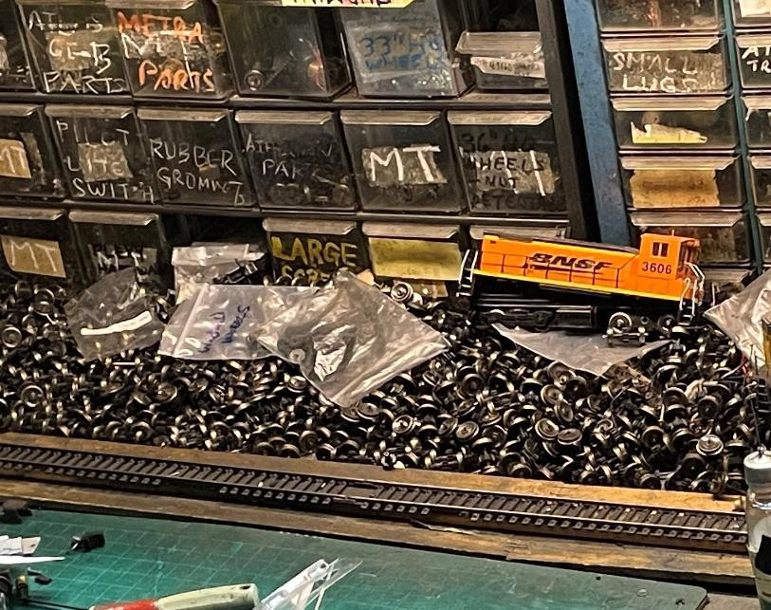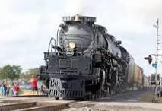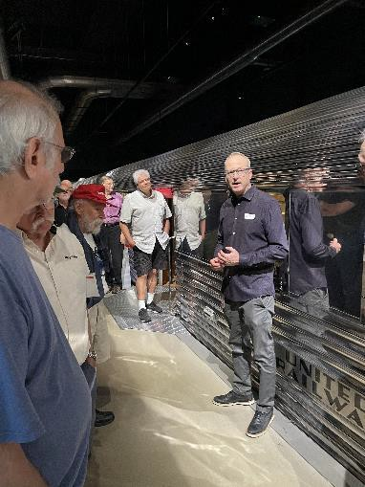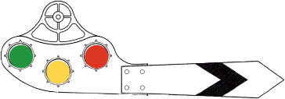

Continued, next page

Exhibit Designer John Llewellyn standing next to the Pioneer Zephyr, explains how the exhibit has evolved over time.

**At MSI**

Continued

Right: FVD group in front of the Pioneer Zephyr

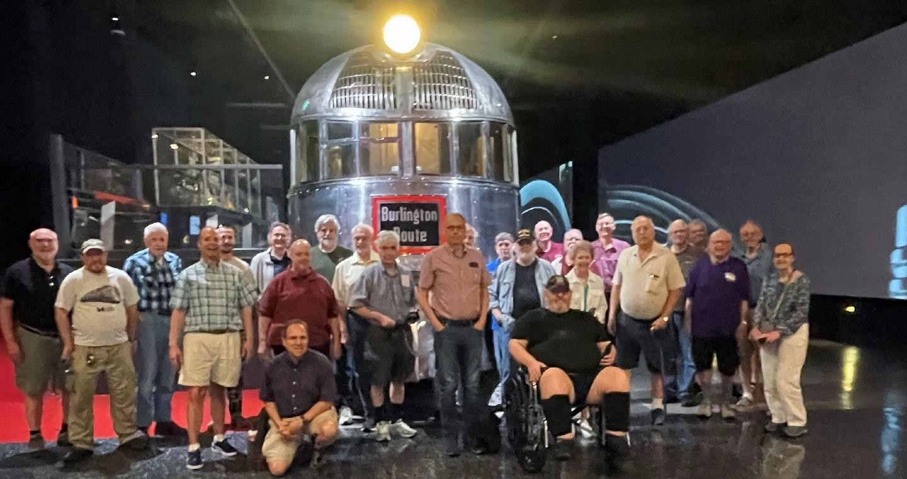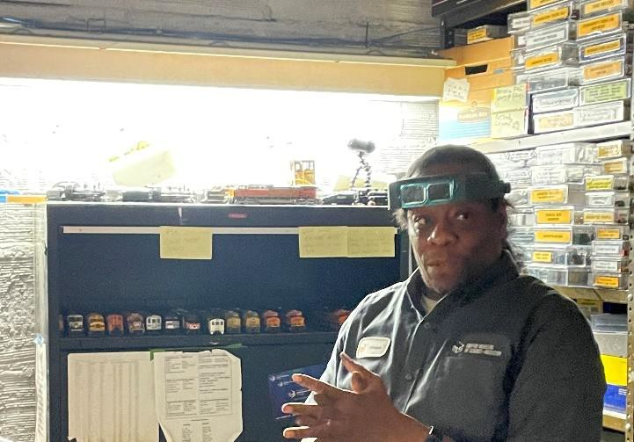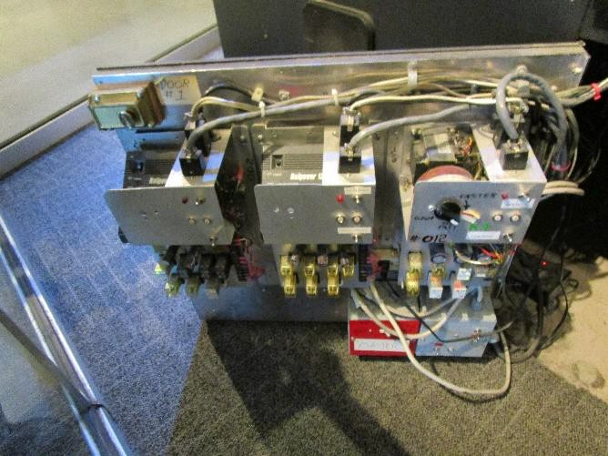

Right: William Davidson gives insight on daily train maintenance.

Far Right: One of several relay panels controlling the layout.

The Great Train Story is a 3500 square foot HO scale model railroad display located in the Transportation Zone at MSI. Taking over 2 ½ years, it was designed and built at a cost of $3.5 million.

Trains have been rolling on the layout since 2002, 363 days a year, at least eight hours a day. That's a lot of miles, *real* miles not scale ones, for *scale* trains, not real ones. How do they hold up under a duty cycle they were not designed for? Not great, according to William Davidson, who is responsible for keeping them running. There is a lot of wear and tear on parts that are in constant motion. Wheels are the biggest wear item, followed by motors. William keeps parts in his workshop next to the exhibit, reusing and recycling what he can.

At the turn of the 21st century DCC was deemed not ready for heavy daily use. The design team instead kept with DC block control, driven by ten panels of solid-state relays hidden at various points below the layout. There are no computers in sight.

William is constantly replacing and updating the layout, but the changes are gradual. Only if you’re a frequent visitor will you notice them. Thanks to the generosity of the folks at MSI, we’ll be back.

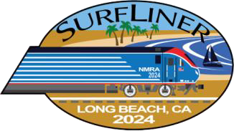

Upcoming Events

* [**Surfliner 2024 NMRA convention**](https://surfliner2024.org/) **August 4-11, Long Beach CA**

Held at the Westin Long Beach, the annual convention includes over 100 clinics and tours

* [**Next FVD Meeting**](https://foxvalleydivision.org/fvd2016/timetable.v2.html) **Sunday, September 22, 1:30 PM at Gary Morava Recreation Center and Zoom**

Held monthly on the third Sunday at 1:30. Zoom link will be sent prior to the meeting

* [**Big Boy 4014 Whistle Stop, Rochelle IL**](https://www.cityofrochelle.net/union-pacifics-big-boy-4014-steam-engine-to-visit-rochelle/) **September 8**

Check website for time and location

* [**Great Midwest Train Show**](https://www.greenbergshows.com/gmtspages/great-midwest-train-show-information) **August 4 & September 8, 9 AM – 3 PM**

DuPage County Fairgrounds, Wheaton IL

C:\Documents and Settings\tamic\Desktop\TC999D\TC9990301D-PB\TC9990301-IMG04.jpg

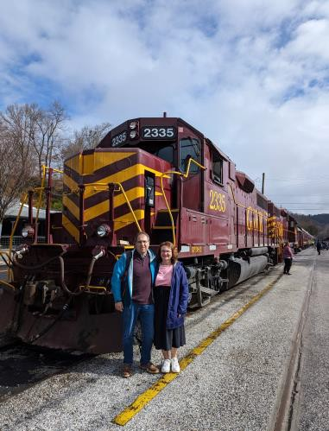

**got trains?**

**Riding one, running a model, laying track, assembling scale structures, debugging hardware/software, looking at art, visiting a museum, just thinking about them? Got an interesting story to tell? We're story spotters, looking for people to share their experience (or lack thereof)! Contact Chris Mattimiro,** [**cmattimiro@outlook.com**](mailto:cmattimiro@outlook.com)**.**

**About the Fox Valley Division**

**Superintendent**: Michael Hirvela

**Asst. Superintendent**: Denis Zamirowski

**Paymaster**: Bob Landwehr **Chief Clerk**: Richard Hoker **Achievements & Contests**: Jim

Landwehr

**Clinics & Programs**: Gary Saxton

**Membership Promotions**: Michael Hirvela

**Membership Services**: Erich Abens

**Public Relations & Social Media**: Keith Dart

**Webmaster**: Jim Osborn, MMR®

**Semaphore Editor**: Chris Mattimiro

We encourage you to take advantage of all the FVD has to offer. We are here to answer your questions, help improve your modeling, and help you better enjoy the great hobby of model railroading. Visit us on the [web](https://foxvalleydivision.org/)!

**Mailing Address:**

Fox Valley Division PO Box 1535

Arlington Heights IL 60005-1535

**Website**:

<https://foxvalleydivision.org/>

**Facebook:**

<https://www.facebook.com/fvdnmra/>

If you receive this newsletter you live in the Midwest Region, Fox Valley Division of the National Model Railroad Association (NMRA). The Fox Valley Division (FVD) includes all of Lake and McHenry, as well as parts of Cook and Kane Counties in northeast Illinois. About 180 members of varied ages and modeling ability belong to the FVD. Most modeling scales are represented in our division. Subscriptions to the Semaphore newsletters are free. Membership in the division is available through the NMRA at: <https://www.nmra.org/>

Monthly FVD meetings run September through May in-person and online via [Zoom](https://zoom.us/). Each meeting features a clinic, model contest, and information of interest to the membership. Outings, layout tours, and operating sessions may also be held.

**About the Semaphore**

The Semaphore is published by the Fox Valley Division of the Midwest Region of the NMRA, a registered 501(c)(7) not- for-profit Illinois corporation.

**Staff**:

Editor: Chris Mattimiro Assistant Editor: Michael Hirvela Assistant Editor: Jim Osborn

