MONTHLY NEWSLETTER OF THE FOX VALLEY DIVISION, NMRA

The Semaphore

**In this issue**

M A Y 202 4

**Mike’s Minute P.1 MI City Tour Recap P.2 FVD’s going to MSI! P.2 Upcoming Events P.3 Contact Information P.4**

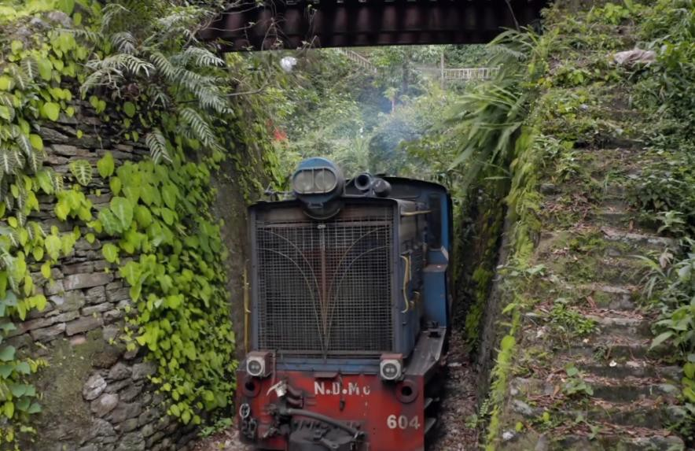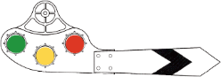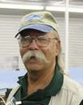

***Toy* Train?**

Engine 604 of the Darjeeling Himalayan Railway squeezes under a bridge along its 88 km route. The DHR (also called the Toy Train) is a narrow-gauge (2 ft) passenger rail service built between 1879 and 1881. It features coal- fired steam and diesel locos. [DHR](https://www.pbs.org/video/darjeeling-himalayan-railyway-rfacj6/) is one of the railways featured on [Epic Train Journeys From Above](https://www.pbs.org/show/epic-train-journeys/) streaming on [PBS Passport](https://www.pbs.org/). Watch and get some good modeling ideas!

With our annual member meeting and the monthly member meetings behind us, we are looking to wrap up our 2023-2024 season with the May meeting held at the

Morava Recreation Center in Prospect Heights. For next season’s (2024-2025) start, it appears that the first couple of meetings commencing in September, also will be at the Morava Center. The schedule for our 2024-2025 season will be forthcoming in a future edition of the “Orange Card.” Watch for it in August.

Summer in northeastern Illinois has a myriad of railroad-related and railroad-themed activities throughout our area. We are fortunate to live so close to several well- respected museums and operating demonstration railroads you can visit in a few hours. Some members also take the opportunity to venture further and visit other locations of renown. If you go to any of these this summer, take your still or video camera and record some memories. Bring them to an FVD member meeting and share your adventure with us.

Mike’s Minute

Please join us as our 2024-2025 season gets started on September 22nd at the Morava Center in Prospect Heights. As much as we’d like to see you in person, we hold hybrid meetings over Zoom as well. Whichever method (in person or over the net) you select to participate, I appreciate you taking the time and effort to attend, and I hope you find the new season’s presentations interesting and informative. We’re continually trying.

Regards, Mike Hirvela

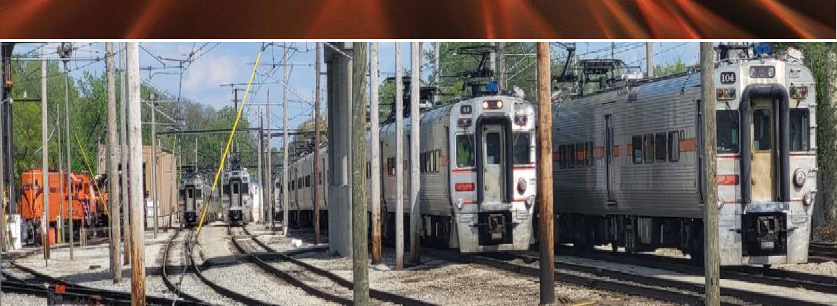

**Michigan City South Shore Shop Tour** *– Denis Zamirowski*

On May 4th in conjunction with the MWR NMRA Around The Bend Convention in South Bend, Indiana 29 members toured the South Shore Shops. On the trip from South Bend, we were treated to a travelogue courtesy of the Friends of the South Shore who were on an excursion to Chicago.

Upon arrival in Michigan City, our group of 29 was welcomed by the Planning Engineer and a retired employee who both conducted the tour of the shops. We learned how at points in the service life of the cars they are completely stripped down and rebuilt (this includes removing the whole interior including windows, doors, floors, electrical, etc

.). Then, all exterior equipment is removed including trucks, controls, and pantographs. In essence, a whole new car is built and updated to FRA standards with cameras and other equipment added.

During our tour, we learned how the South Shore had changed the propulsion system from DC to AC (custom by Toshiba) and gets seven years between motor rebuilds versus a few months.

We saw shops and equipment that was used for truing wheels, rebuilding trucks, and motors that has been around in the same shop since 1926 and still is working on modern equipment.

It was an amazing tour where we learned how a crew of about twenty-five craftsmen can rebuild equipment including: electrical, mechanical, and even upholstery and carpentry. They can rebuild everything except pantographs, control systems, and motors.

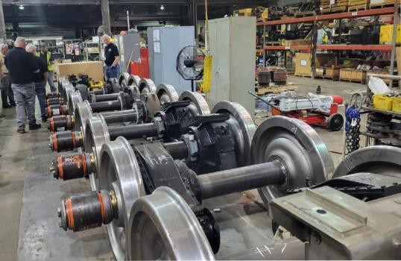

Around The Bend Convention Wrap-Up

Feedback from attendees of the convention, held May 2-4 in South Bend has been very positive. Over 150 people were in attendance, and the Michiana Division financials were in the black!

# Confirmed: Museum of Science and Industry Trains Tour

The limited-group tour of the Pioneer Zephyr and Great Train Layout is confirmed for June 21! All participant slots are booked, but you can add your name to the [waitlist](https://docs.google.com/forms/d/e/1FAIpQLSc4YLpJnwIWeMJCmyQuY7P3IgTHCTiEDUSyEfDEUw_er1FAxg/viewform?usp=sf_link) if you wish. Those who are signed up will receive an email confirmation and directions within a few days.



# Next FVD Meeting

**When:** Sunday, May 19, 1:30 PM

**Where:** [Gary Morava Recreation Center](https://phparks.org/location/gary-morava-recreation-center/) and [Zoom](https://zoom.us/)

**Presentation:** *Operations at the San Diego Model Railroad Museum* by Bob Wundrock, MMR®, SCWD.

# Bob will be presenting a clinic featuring his ops session visit to the San Diego Model Railroad Museum in 2009. In it he'll also cover some history plus photos and video from each of the five layouts in the museum.**Contest:** One Steam or Diesel Yard Switcher

**Model Achievement Celebration Display Category:** Up to 3 Freight Cars with an Open Load

**Show & Tell:** Display any category or train related item

# Upcoming Events

## Monthly FVD Meetings

Held the third Sunday of every month at either the [Glenview Public Library](https://glenviewpl.org/) or the [Gary Morava Recreation Center](https://phparks.org/location/gary-morava-recreation-center/), the meetings are an opportunity to share information, either in-person or on Zoom. The May 19 session is the last meeting of the season. We will resume at Morava Center on September 22. Next season’s schedule will be posted on the [FVD website](https://foxvalleydivision.org/fvd2016/timetable.v2.html) no later than August.

## Illinois Railway Museum Events

[C&NW Day at Illinois Railroad Museum](https://www.irm.org/event/chicago-north-western-weekend/?mc_cid=9ccf50ca14&mc_eid=aef624253e) May 18, 11 AM – 4 PM [Dining à la Zephyr](https://www.irm.org/event/memorial-day-weekend/?mc_cid=9ccf50ca14&mc_eid=aef624253e) May 25, 26, 5 PM

## Other Events

[Pullman Railroad Days](https://www.pullmanil.org/event/pullman-railroad-days-2024/) June 1, 9 AM – 5 PM at [Pullman National Historical Park](https://www.pullmanil.org/event/pullman-railroad-days-2024/) [Franklin Park Railroad days](https://foxvalleydivision.org/fvd2016/imagesfvd2016/events/2024fptrainflyer.pdf) June 8, 10 AM – 3 PM in [Franklin Park, IL](https://maps.app.goo.gl/YpffpNawiiVnUfoC9)

FVD Museum Train Exhibits Tour June 21, 9 AM – 3 PM at the Museum of Science and Industry. [Signup required](https://docs.google.com/forms/d/e/1FAIpQLSc4YLpJnwIWeMJCmyQuY7P3IgTHCTiEDUSyEfDEUw_er1FAxg/viewform?usp=sf_link)

## Train Shows

[Great Midwest Train Shows](https://www.trainshow.com/) are held monthly at the [DuPage Event Center and](https://dupagecountyfair.org/dupage-county-fair/#general) [Fairgrounds](https://dupagecountyfair.org/dupage-county-fair/#general) in Wheaton. Information can be found on [Trainshow.com](https://www.trainshow.com/).



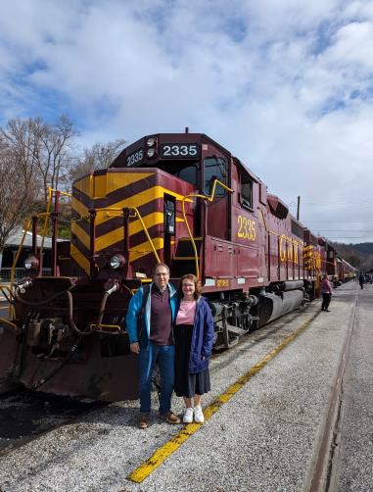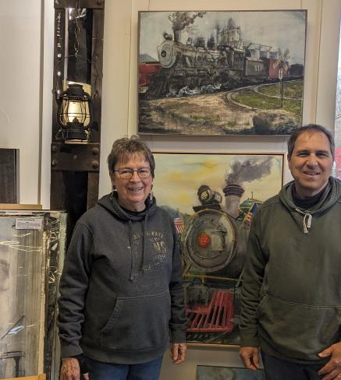

**got trains?**

**Riding one, running a model, laying track, assembling scale structures, debugging hardware/software, looking at art, visiting a museum, just thinking about them? Got an interesting story to tell? We're story spotters, looking for people to share their experience (or lack thereof)! Contact Chris Mattimiro,** [**cmattimiro@outlook.com**](mailto:cmattimiro@outlook.com)**.**

About the Fox Valley Division **Superintendent**: Michael Hirvela **Asst. Superintendent**: Denis

Board of Directors



Zamirowski **Paymaster**: Richard Sieben **Chief Clerk**: Richard Hoker **Achievements & Contests**: Jim

Landwehr

**Clinics & Programs**: Gary Saxton

**Membership Promotions**: Michael Hirvela

**Membership Services**: Erich Abens

**Public Relations & Social Media**: Keith Dart

**Webmaster**: Jim Osborn, MMR®

**Semaphore Editor**: Chris Mattimiro Contact any board member [here](http://www.foxvalleydivision.org/fvd2016/contactus.v2.html).

About the Semaphore

The Semaphore is published by the Fox Valley Division of the Midwest Region of the NMRA, a registered 501(c)(7) not-for-profit Illinois corporation.

**Staff**:

information of interest to the membership. Outings, layout tours, and operating sessions may also be held.

We encourage you to take advantage of all the FVD has to offer. We are here to answer your questions, help improve your modeling, and help you better enjoy the great hobby of model railroading. Visit us on the [web](https://foxvalleydivision.org/)!

**Mailing Address:**

Fox Valley Division PO Box 1535

Arlington Heights IL 60005-1535

**Website**:

<https://foxvalleydivision.org/>

**Facebook:**

<https://www.facebook.com/fvdnmra/>

Editor: Chris Mattimiro Assistant Editor: Michael Hirvela Assistant Editor: Jim Osborn

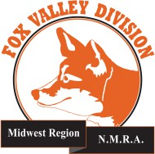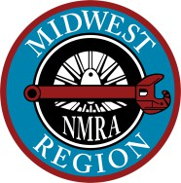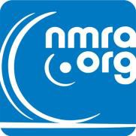

© 2024 by the Fox Valley Division of the NMRA, Inc.

If you receive this newsletter you live in the Midwest Region, Fox Valley Division of the National Model Railroad Association (NMRA). The Fox Valley Division (FVD) includes all of Lake and McHenry, as well as parts of Cook and Kane Counties in northeast Illinois. About 180 members of varied ages and modeling ability belong to the FVD. Most modeling scales are represented in our division.

Subscriptions to the Semaphore newsletters are free. Membership in the division is available through the NMRA at: <https://www.nmra.org/>

Monthly FVD meetings run September through May in-person and online via [Zoom](https://zoom.us/). Each meeting features a clinic, model contest, and