MONTHLY NEWSLETTER OF THE FOX VALLEY DIVISION, NMRA

The Semaphore
In this issue
M A R C H 2 0 2 4
Mike’s Minute P.1 Next FVD Meeting P.2
New Member Welcome P.2 Upcoming Events P.3 Contest Calendar P.4 Contact Information P.4

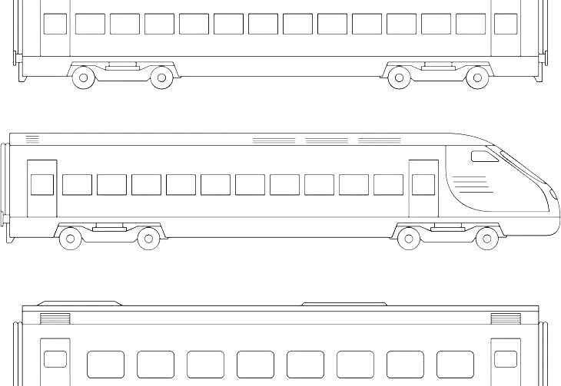
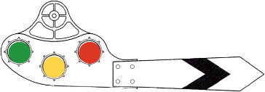
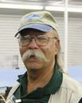

SPRING is almost here as we kick the clock ahead one hour and the following week Spring officially arrives. I know our members are looking forward to the change of seasons and saying goodbye to Winter. We sadly also have to say goodbye to some influential hobby people: Jim Hediger, long-time Editor at Model Railroader Magazine, and Rolf Plachter of Racine, Wis.
Many of you know Mr. Hediger from the many articles he authored in MR Magazine over a 40- year career. His Ohio Southern model RR was one of the first to utilize a helix in its construction. I had the fortunate opportunity to visit his home and the OS during a Mid-West Region convention some years ago. It was smaller than I envisioned from the magazine description but was running smoothly and was a joy to see in person. Mr. Plachter, while not a household name south of the Wisconsin-Illinois border, built the MidWest Lines in four rooms of his basement. He and his RR have been featured in MR and in video on Trains.com. I have had the pleasure of operating the MWL twice a month for the past several years. When Jim Allen asked me what this operations thing was all about and could we go somewhere and see
Mike’s Minute
it in action, we went to Rolf’s. Jim found out Rolf was an old machinist by trade, and they spent most of the night talking machinery, while enjoying the railroad. Jim and I still go to Rolf’s as it is too nice not to visit. It was fun to see Rolf smile while watching us making his creation come to life. He still had a handshake like a vise-grip even the week before he passed quietly. I will miss him.
Our March and April meetings will be held at the Glenview Public Library. Holding our meeting at the GPL helps us stretch our budget. If you know of another good meeting location, please let an official or Board member know. We (the Board) have had discussions regarding moving the meeting location around the division, but location and cost are always stumbling blocks. Your input and feedback on the use of these facilities will be of great help in determining where we meet in the future. Our May meeting will be at the Morava Recreation Center in Prospect Heights. It wraps up our season. The schedule for our 2024-2025 season will be forthcoming. Watch for the “Orange Card” in the mail.
Mike’s Minute continued, next page.

Mike’s Minute continued
Join us at our gatherings and meet modelers who have similar and varied interests. Whichever method (in person or online) you select to participate, I appreciate you taking the time and effort to attend, and I hope you found the presentations
interesting and informative. We’re trying. Regards, Mike Hirvela

Next FVD Meeting
When: Sunday, March 17, 2024, 2:00 PM
Where: Glenview Public Library and Zoom
Presentation: Santa Fe livestock movement by Steve Sandifier, MMR
In the years prior to 1970 it was common to see stock cars on American Railroads. Horses (primarily until the 30s), cattle, sheep, goats, and hogs were regularly shipped across the country to provide horsepower and food for Americans. Since these are living creatures, special treatment was necessary to keep livestock from becoming dead freight! And yes, you could find the stockcar hauling grain, tomatoes, or rail. Steve will discuss the procedures, rules, forms, cars, stock pens, feeding stations - everything required to make this industry function.
Bring for Display: Up to 3 steam locomotives

Welcome New Members!
Say hello to those who have joined us in 2024 (so far):
- Thomas Schulty, Mt. Prospect
- Jeff Shcramuk, Huntley
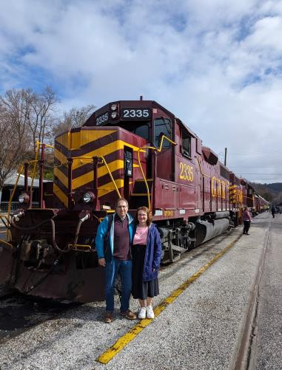
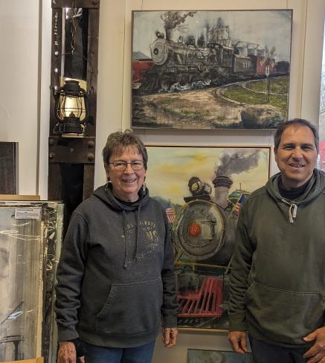
got trains?
Riding one, running a model, laying track, assembling scale structures, debugging hardware/software, looking at art, visiting a museum, just thinking about them? Got an interesting story to tell? We're story spotters, looking for people to share their experience (or lack thereof)! Contact Chris Mattimiro, cmattimiro@outlook.com.

Upcoming Events

Monthly FVD Meetings
Held the third Sunday of every month at either the Glenview Public Library or the Gary Morava Recreation Center, the meetings are an opportunity to share information, either in-person or on Zoom. Here is the meeting schedule through the end of the year. See the full schedule on the FVD website.
When | Where
3/17/24 2 PM | Glenview Public Library and Zoom
4/21/24 2 PM | Glenview Public Library and Zoom
5/19/24 2 PM | Gary Morava Recreation center and Zoom

Midwest Regional Meetings
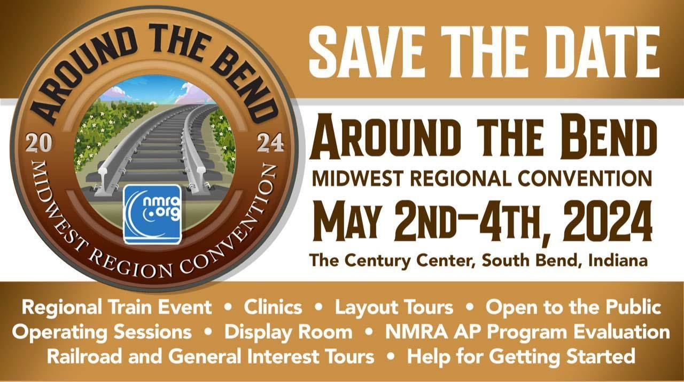
Around the Bend Convention Information and Promotion Video
- Club Events & Shows (click links for more information)
March O Scale Meet March 14-17: Westin Lombard at Yorktown Center, 70 Yorktown Center, Lombard, IL, 60148.
Rock River Valley Division Train Show March 16-17, Saturday 10-5, Sunday 10-
3. Harlem High School, 9229 N Alpine Rd, Machesney Park IL
A Day at the Archives – A weekend to benefit multiple train archive efforts. April 6, 10 AM – 9 PM. VFW Post 1197, 645 S River St, Batavia IL
Lionel Model Railroad Club Open House April 13-14. Parkland Plaza, 2721 S Calhoun Rd, New Berlin, WI 53151
Great Midwest Train Shows are held monthly at the DuPage Event Center and Fairgrounds in Wheaton. Information on both shows can be found on Trainshow.com.

Division Meeting Date | Contest
March 17 | Up to three steam locomotive
April 21 | Up to three Refrigerated Billboard Cars
May 19 | Up to three Freight Cars with an Open Load

About the Fox Valley Division

Contest rules
Future contests be held in person at the meet. There will be no photographic entries. All entries will ONLY be displayed at the meet.
Contest Calendar
Board of Directors
Superintendent: Michael Hirvela
Asst. Superintendent: Denis Zamirowski
Paymaster: Richard Sieben Chief Clerk: Richard Hoker Achievements & Contests: Jim
Landwehr
Clinics & Programs: Gary Saxton

Membership Promotions: Michael Hirvela
Membership Services: Erich Abens
Public Relations & Social Media: Keith Dart
Webmaster: Jim Osborn, MMR®
Semaphore Editor: Chris Mattimiro Contact any board member here.

About the Semaphore
The Semaphore is published by the Fox Valley Division of the Midwest Region of the NMRA, a registered 501(c)(7) not-for-profit Illinois corporation.

Staff:
Editor: Chris Mattimiro Assistant Editor: Michael Hirvela Assistant Editor: Jim Osborn
information of interest to the membership. Outings, layout tours, and operating sessions may also be held.
We encourage you to take advantage of all the FVD has to offer. We are here to answer your questions, help improve your modeling, and help you better enjoy the great hobby of model railroading. Visit us on the web!
Mailing Address:
Fox Valley Division PO Box 1535
Arlington Heights IL 60005-1535
Website:
https://foxvalleydivision.org/
Facebook:
https://www.facebook.com/fvdnmra/

.
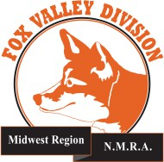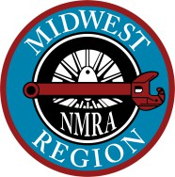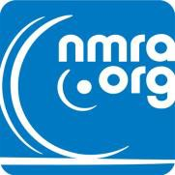

© 2024 by the Fox Valley Division of the NMRA, Inc.
If you receive this newsletter you live in the Midwest Region, Fox Valley Division of the National Model Railroad Association (NMRA). The Fox Valley Division (FVD) includes all of Lake and McHenry, as well as parts of Cook and Kane Counties in northeast Illinois. About 180 members of varied ages and modeling ability belong to the FVD. Most modeling scales are represented in our division.
Subscriptions to the Semaphore newsletters are free. Membership in the division is available through the NMRA at: https://www.nmra.org/
Monthly FVD meetings run September through May in-person and online via Zoom. Each meeting features a clinic, model contest, and

