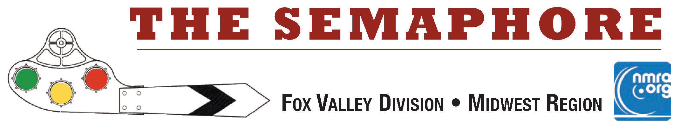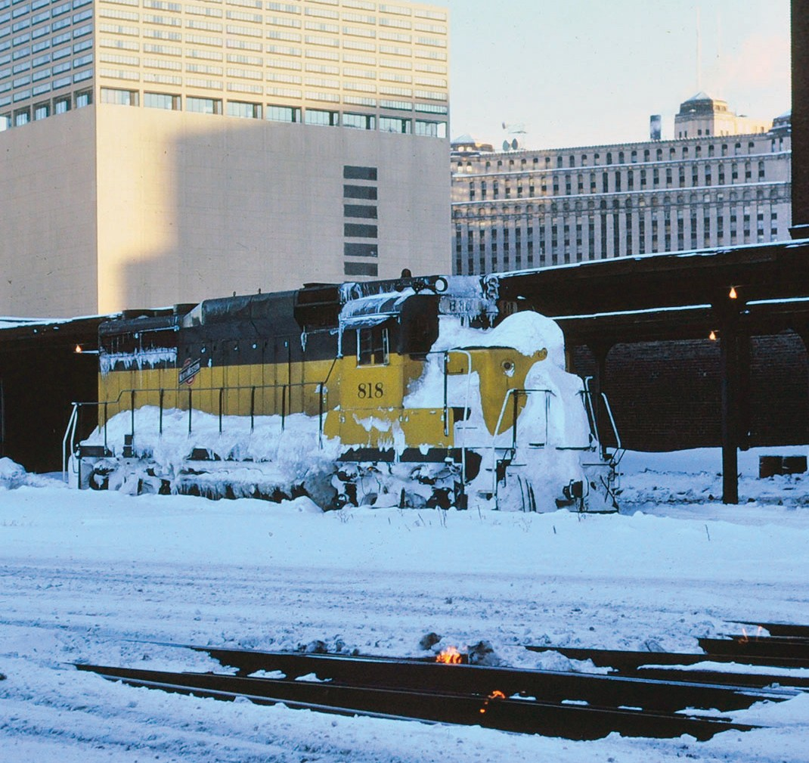March 2023
March 2023

Mark Llanuza has shared some winter prototype photos with the Semaphore. A GP-30 is posing for Mark at the C & NW Terminal Station (aka Clinton Ave. Station) above. He's sent in photos taken at Wheaton, IL on the Clinton Sub and Arlington Heights on the Harvard Sub follow. We always appreciate Mark's photography so put on your heavy coat and gloves as you scan a few of Mark's winter photos in "The storm of January 1979" photo essay to follow. The story continues at the bottom of page 2. Seeing this photo reminds me of the innocent question from a fellow passenger, "Why are the tracks on fire?"

Keep those Trains Moving by Jim Osborn, MMR®...
In This Issue...

Page 1-5 Mark Llanuza Winter Photos Page 2 Keep those trains moving Page 6 Mike's Minute
Page 7 Contest Results & Next Meet Page 8 What's Happening (or not) Page 9 Meeting Schedules
Page 10 Help Wanted!
Page 10 Division Information
Or more specifically this month, the Fox Valley Division! We have the annual election of officers just around the bend at our Annual FVD Business meeting on April 16, 2023. The 2 year terms for Assistant Superintendent and Paymaster are up and we will vote to fill the next 2 year terms at that meeting. Reports from all the Trainmasters will also be on the meeting agenda.

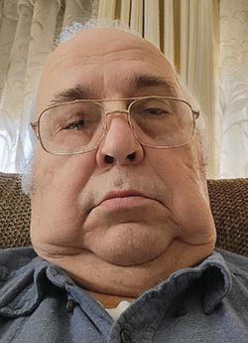
So far we have two candidates that are interested in the two positions: Denis Zamirowski for Assistant Super, and Rich Sieben for Paymaster. Their biographies are below. Nominations will also be accepted from the floor at the meeting.

Denis Zamirowski for Assistant Superintendent
(Incumbent)
I became interested in trains when I was about four years old and went with my family to the 1949 Railroad Fair on the Chicago lakefront. I guess the size and mechanisms of these huge locomotives would fascinate
any four year old. My first train set was American Flyer. Later on, I was intrigued by my Uncle’s layout and the big layout at the Museum of Science and Industry and decided to build my own. I sent away and bought and built a Mantua locomotive kit at about age fourteen (it still runs). I joined the NMRA over 25 years ago and became involved in the old North Shore and Western Division and then the Fox Valley Division after the merger. I have been a volunteer for many High Wheeler shows, an I-Hobby Show, the Midwest Region Convention in Schaumburg and the Fox Valley Division since Bob Schlemon moved away. I serve as proxy for our Superintendent at Midwest Region meetings. I also pick up refreshments for our Division meetings. I hope to serve effectively for another term.

Rich Sieben for Paymaster

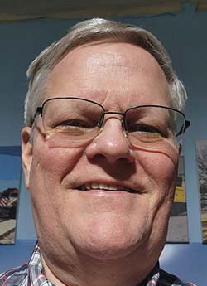
Hi, my name is Rich Sieben and I'm running for the Paymaster Trainmaster. I'm a life-long model railroader having an interest in trains since as far back as i can remember. I grew up in Chicago nearby the river junction on the old Chicago and North Western. I model in N scale and you may have seen my
layout at one of the FVD virtual meetings where i showed a little bit of the layout. I'm modeling the Chicago industrial switching district. I have my layout in the area of my 2 car garage and it has 180 industrial spots, 11 yards and over 350 switches. It's an interesting and challenging switching district since i can keep more than 10 people busy when we operate the layout. I'm running for the FVD Paymaster Trainmaster. During the day I'm the energy manager for Metra, the local commuter railroad. I'm a CPA and also have my MBA. Thank you.

Speaking of Paymaster, Tim Kleimeyer is retiring from the Paymaster Officer position. We all owe a huge Thank You to Tim for his years of service to the division as Paymaster as well as Assistant Superintendent. We are fortunate to have him in our ranks!

I know I sound like a broken record - but - the FVD really needs your help. We have several vacant Trainmaster positions that are being temporarily covered by members with multiple assignments. Membership Promotions, Ways and Means, and my job, the Semaphore Editor. We also should have more than single candidates for the officer positions. As my Mom used to say, "Many hands make for little work!" (That statement was usually followed by "Now get to work!" But that's another story.)

You get my point. Jump in and help lighten the load of the division administration!

Take care, stay safe, And Keep Those Trains Moving!
Jim Osborn, MMR®, Editor

Winter Prototype Photography by Mark Llanuza...

Your Semaphore Editor asked me if I would like to share some of my winter train shots - so here I am with a little story told with the photos. Many of you know me by now but for those that do not I love to photograph trains - especially in inclement weather. While everyone is inside
--I am out waiting for the next express to plow through a snow drift.

Winter Prototype Photography by Mark Llanuza continued...
Lets get started with the storm beginning Saturday Jan 13, 1979. I started off leaving from Arlington Hts IL where I was living at the time. I left early morning toward the Rock Island line to try to capture the big Rock Island trains with E-units pulling freight and passenger service.

I found the line was essentially shut down so I headed to Wheaton, IL for some CNW action. It was around noon time when I got there and snow was deep and getting worse by the hour. We already had a foot of snow on the ground from the Jan 1st blizzard and this storm was adding plenty more. I was there till dark -- getting lucky photographing commuter trains. The snow was blowing hard but gave me awesome scenes to photograph.

Then I really got lucky when I spotted a snow plow extra coming down the center track with four units shoving a Jordan Spreader cleaning all the snow off the main lines. An hour later I got a great shot of a westbound freight plowing deep snow to end the day. Here are some of the photos from that day.

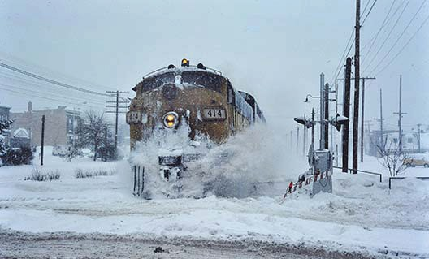
CNW F Unit # 414 with gallery cars near Wheaton Station January 1979.

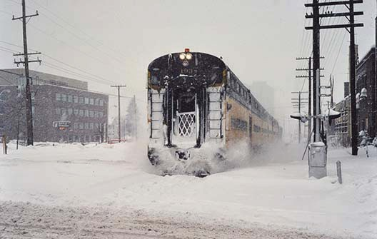
CNW Cab car #193 approaching Wheaton Station January 1979.

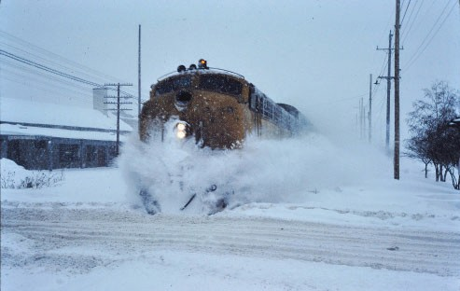
CNW Commuter train near Wheaton station in January 1979.
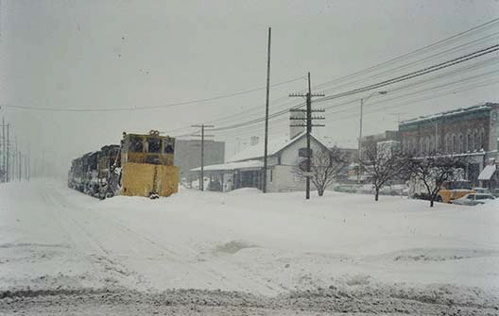

CNW snow plow extra at Wheaton IL Four Geeps pushing a Jordan Spreader Jan 13th 1979.
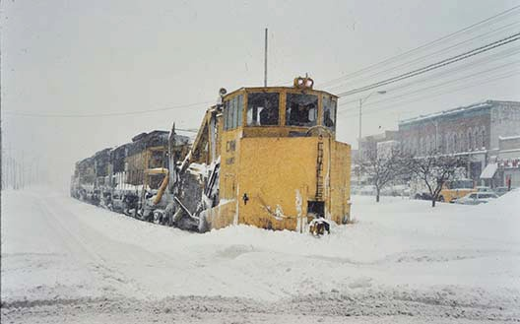

After being out all night, I got some great shots on the Harvard sub near Arlington Heights. Follow along and check those out the next page.

Winter Prototype Photography by Mark Llanuza, continued...

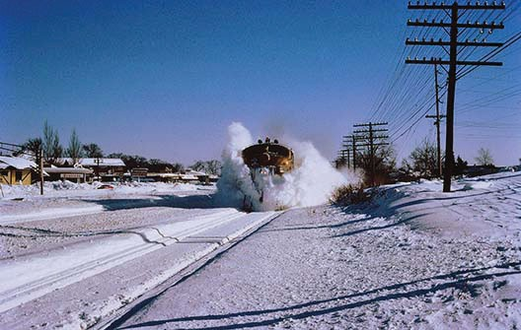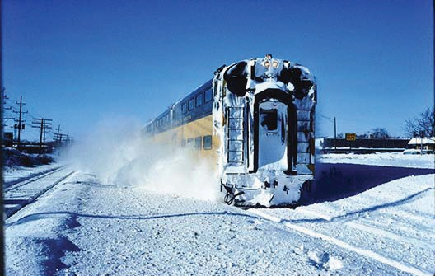

CNW 423 pulling coaches near Arlington Heights.
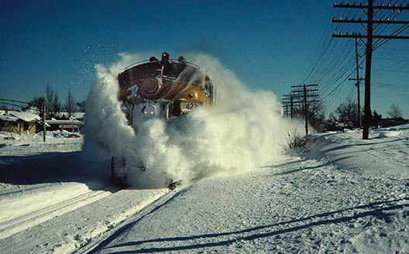

I think I am going to get dusted by CNW 423!
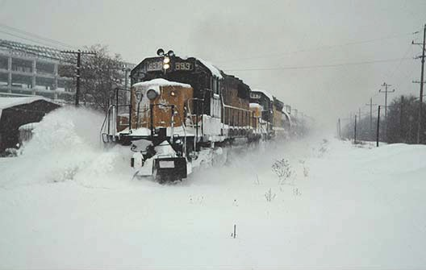

A tank extra plowing some snow at Arlington, Heights. January 1979.
A CNW commuter pushing near Euclid Road in Arlington Heights. The cab car number is unrecognizable.
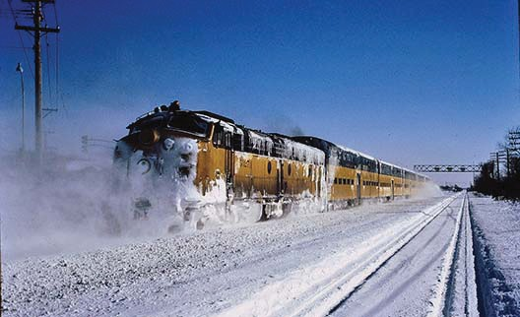
The back end of that commuter as it passes by.
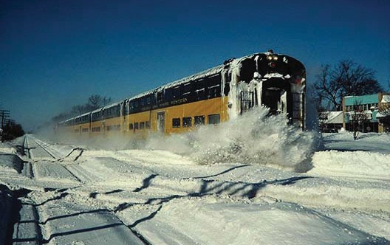

Cab car #178 at Euclid Avenue on the Harvard sub divi- sion in Arlington Heights.

Winter Prototype Photography by Mark Llanuza, continued...
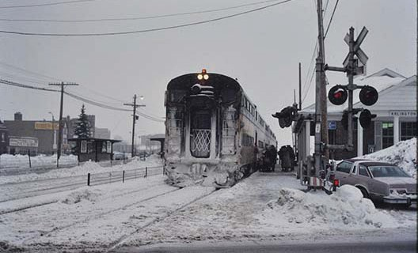
Frozen commuters boarding a frozen train at Arlington Heights, January 16, 1979

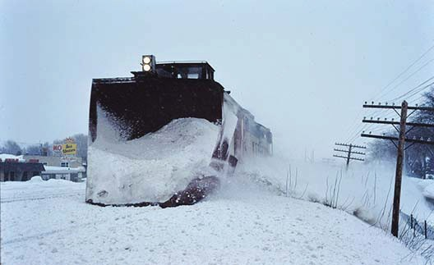
A CNW Russel snow plow extra near Arlington Heights station. January 16, 1979

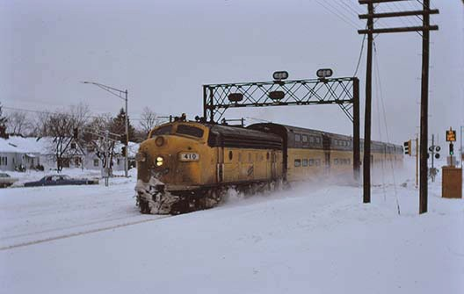
CNW # 410 with a three car set heading westbound. January 16, 1979

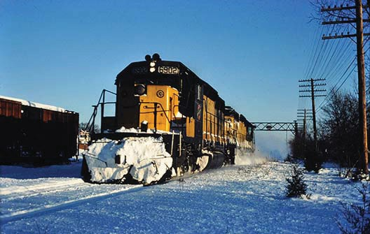

SD-40 #6902 is plowing some light snow after the big storm.
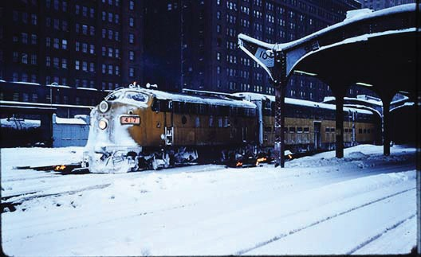

I'll finish up with a couple of photos of the action at Clinton Avenue Station after the storm.
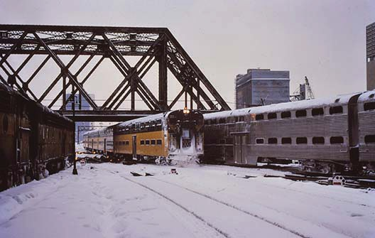
Thanks for watching. I hope you enjoyed the snow show. Mark Llanuza.....

Mike's Minute ...
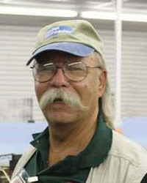
This is my after-the-train-show minute and it seems I don’t have a great resource of energy left - so my fingers are on auto-pilot. I heard our last FVD member meeting was successful and Denis managed the meeting well. Many compliments were expressed about the presentation on
Interchanges by Scott Payne. It was professionally done and there were several follow-up questions and comments as a result. BTW, Scott left us his contact information and an invitation to see his layout. If you have further questions or would like to visit his layout -- use the link below to reach out to either the Super (me) or Webmaster for his contact information. He lives in Sheboygan, WI and would be glad to host you for a visit. Thanks Scott!

https://www.foxvalleydivision.org/fvd2016/contactus.v2.html

I am gratified our Clinic and Programs Trainmaster, Gary Saxton, continues to find interesting and informative information sessions for our members to enjoy. Don’t forget, YOU CAN DO THIS, too, and if you have a topic you thing others may like, let us know and we’ll help you get it up on the screen. I know from personal experience getting up in front of a group of folks is not as nerve-wracking as it appears, and doing so does provide some confidence building.

As some of you know, I couldn’t make the FVD Member meeting on February 19. I was involved with the Bluff City Modular Engineers HO modular layout at the Mad City Train Show -- it was our first display since TrainFest 2019. Jim Allen, Art Jones and I worked diligently on replacing four 2-ft x 4-ft modules and making one new 2-ft x 6-ft module themed using the Walthers’ car float barge. We also added some structure and street lighting to the re- built and new modules using the Woodland Scenics’“Just- Plug” system.

We were located in the NE corner of the hall, so we were the first in at 9 am on Friday and the last out at 7 pm on Sunday. It was a long but eventful weekend. The Bluff City Modular Railroad was awarded Second Place – Module Layout by the show sponsors: South Central Wisconsin Division NMRA. It occurred to me after we returned from the show that of the 31 layouts on display, we were in the top 3! The 1st Place layout was the Santa Fe All The Way layout and the BEST IN SHOW layout was the Mid-West ModuTrak. Both groups have outstanding displays. I guess all the work we did over almost 2.5 years paid off.

Last month I noted we have a display of RR items in the main lobby display case at the Mt. Prospect Public Library. We had items in this case for January and have other items in the case for February. We will be changing the display at the end of the month to the meeting room display case for March. If you have an item, be it a special car, locomotive, a signboard, a RR plaque, or some railroadiana, let me know to expect you at the Mt. Prospect Public Library. We change the main lobby display items on February 28 about 10 am. We should be loading the meeting room display case on March 1st.

Our FVD meeting notices come out via e-mail before our meeting date, so please be sure we have your current e-mail address and advise of any change. Our webmaster sends out the meeting notice with the ZOOM system log- on credentials to make it easy to use the Zoom system if you’d rather participate that way. Whichever method you select to participate, I appreciate you taking the time and effort to attend. You can see the full schedule, clinics and contest topics at:
https://www.foxvalleydivision.org/fvd2016/timetable.v2.html

Regards, Mike Hirvela, Superintendent

Fun Stuff by Jim Osborn, MMR®...

There's a link "floating" around the web about an unusual location for a model railroad. Take a look - this is a first for me!. There's also some great modeling to see on this layout. https://youtube.com/watch?v=4tBrPJ5AbpY&feature=shares
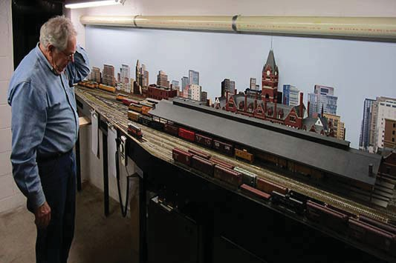
That car has to be here somewhere? I just saw it - darn it - where did it go?

Next Meet - March 19, 2023, 1:30 start. In person at the Gary Morava Center and via Zoom.

Clinic Presentation:
Rerail: Two Prototype Steam Engine Overhauls by Chuck Rita
(Hopefully we will get this presentation to work this time - grrr *&%*$@1#!)

Rail Yard Sale - bring your stuff to sell & bring cash to buy. 10% of the sale proceeds goes to the FVD. Tag your items with a price and your name. Erick Abens will manage the sale for the FVD.

Check the FVD website Timetable for details and updates as they become available.
https://www.foxvalleydivision.org/fvd2016/timetable.v2.html

The February contest featured Illuminated Structures
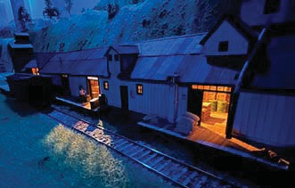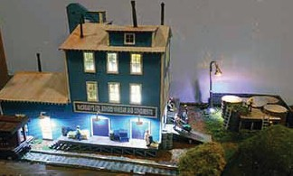
We had 4 entries this month.

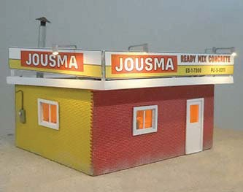
Steven Hayworth's, HO Scale, Kit of the J.J. Harris Warehouse garnered the 1st place popular vote. The model is pictured above left with its interior details and lighting.

Leif Hansen's, HO Scale Laser Kit of McCready's Pickle Packers and Condiments took 2nd Place in the voting. McCready's is shown above. It anchors a great scene on Leif's layout.

3rd place went to Jim Osborn's HO Scale, Scratch Built, Jousma Ready-Mix Concrete Office shown on the left.
See more and larger photos of all the models on our web site at:
https://www.foxvalleydivision.org/fvd2016/contests.v2.html
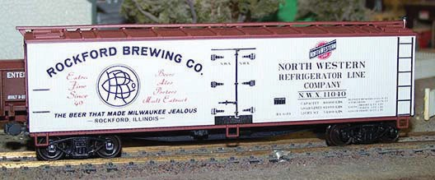
The March Contest Category is Billboard Reefers. Here's an excellent example from last year's contest by Wesley Martin.

Send in up to 3 photos of your models anytime using the our secure upload form:

https://form.jotform.com/201995250508962

What’s Happening - or not ...
The FVD will hold its Annual Rail Yard Sale at the March 19th meet. Bring your unwanted equipment and take this chance to relieve yourself of that extra inventory; find some new goodies and support the division all at the same time. Tag your items with your name & prices. The FVD will retain 10% of all the proceeds from items sold to help fund the division.

You'll enjoy this story on catching a cold at the Illinois Railway Museum.
https://www.theautopian.com/i-caught-a-cold-visiting-americas-largest-train-museum-heres-why-it-was-totally-worth-it/

The Illinois Railroad Museum in Union IL is celebrating their 70th year in existence in 2023.
https://www.irm.org/
The Fox Valley Division will be holding in-person division meets at the Gary Morava Center. The meets will also be broadcast via Zoom. See the next page for details on each meet. We hope to see you there!
Visit the Chicago O Scale Meet in Lombard IL on March 16-19, 2023. Check out their web site for more details: https://marchmeet.net/WP/
Work begins on the UP Challenger #3985. Click on the link to read the Trains Magazine story.
https://www.trains.com/trn/news-reviews/news-wire/work-begins-on-union-pacific-challenger-no-3985/
Great Midwest Train Show (aka: the Wheaton / DuPage Swap Meet) is under new management and is holding swap meets at the DuPage County Fairgrounds in Wheaton, IL. The dates for future shows are generally on the 1st Sunday: March 5, April 2, May 7 and June 4. Follow the signs to the fairgrounds entrance. See: https://www.trainshow.com/
A DAY FOR THE ARCHIVES, at VFW Post 1197, 645 S. River Street (IL Rt3 25), Batavia, IL, - April 1; 9 am.
Sponsored by the BRHS, CNWHS, GNRHS, Lake States, MRHA, Shore Line and SLHTS. Presentations, company stores for the historical societies, buffet dinner. See the society websites for $$ and times.
There will be no Midwest Region Convention scheduled for 2023.
The Rock River Valley Division Train Show will be held on March 25, 10 am - 5 pm & 26, 10 am - 3pm, 2023 Harlem High School, North Alpine Road (south of IL 173), Machesney Park, IL.
The Title Town Train Show will be held on April 9-10, 2023 at the KI Convention Center, Green Bay, WI.
Please see: https://www.ttsgbllc.com/ for all the details.
The FVD will hold its Annual Business Meeting on April 16, 2023. The agenda will include reports from each Trainmaster and the Election of the Assistant Superintendent and Paymaster. Contact the Rich Hoker, Chief Clerk if you are able to run for either of these offices. Contact him at: http://www.foxvalleydivision.org/fvd2016/contactus.v2.html

The Thousand Lakes Region Convention. May 18-21,. 2023. Best Western Plus Bloomington- Mall of America -- Bloomington, Minnesota https://www.thousandlakesregion.org/2021-bismarck-con
The 2023 NMRA National Convention - The Texas Express - August 20 - 26, 2023 Gaylord Texan Resort & Convention Center, 1501 Gaylord Trail, Grapevine, TX 76051 https://www.2023texasexpress.com/

The resurrected Naperville RPM will once again be held in the Chicago area. The dates are October 27 and 28, 2023.

2022-2023 Fox Valley Division Meeting Schedule
Page 9

Meetings are held from 1:30 to about 4:00 pm (except as noted). This season all meetings will be pre- sented online using ZOOM meeting technology as well as in person at the Gary Morava Center. See the timetable on the division’s web site http://www.foxvalleydivision.org/fvd2016/timetable.v2.html for complete instructions on how to use ZOOM and participate in the meetings. For the latest clinic updates and all FVD news and information, visit FVD’s web site at www.foxvalleydivision.org. Save the dates for now - details will follow.

Date

Nov 20, 2022

Dec 18, 2022
Presentation

Grain & Railroads by Mark Vaughan

Two Prototype Steam Engine Overhauls by Chuck Rita
Contest

1 “Over, Under, Around, or Through.”

1 Steam Locomotive.
Notes

Jan 15, 2023
Simplified use of the NCE Switch 1 Diesel Locomotive.

IT-2 and the Switch IT-8 for non- tech folks!
by Mike Wood

Feb 19, 2023

Mar 19, 2023

Next Meet
Interchanges by Scott Payne

Two Prototype Steam Engine Overhauls by Chuck Rita
Rail Yard Sale - bring your stuff to sell and cash to buy more.
1 Illuminated structure.

1 Refrigerated billboard car.

April 16, 2023
Annual Business Meeting and Election of Asst. Superintendent and Paymaster Please contact the Chief Clerk if you are able to run for either of these offices.

May 21, 2023
Presentation: Weathering with Pastels by John Drozdak

History of Cardboard Structures
by Dave Lull
1 freight car with an Open load. 1 structure.

Submit Your Contest Photos anytime at: https://form.jotform.com/201995250508962

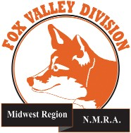
Page10
More Help Wanted ....
The Temporary Semaphore Editor is retiring in May after the 26th issue has been published. Benefits: Fun job , express your creativity, meet other folks in the hobby, work with contributors, improve your spelling, learn stuff, flexible hours and no pay. Interested in keeping the Semaphore alive? Contact the Semaphore editor or any officer at:
http://www.foxvalleydivision.org/fvd2016/contactus.v2.html
The Semaphore is published by the Fox Valley Di- vision of the Midwest Region of the NMRA once a month, ten months a year, from September to June.
The Fox Valley Division of the Midwest Region of the NMRA is registered 501(c)7 not-for-profit Illinois corporation.
About the Fox Valley Division
If you receive this newsletter, you live in the Midwest Region and Fox Valley Division area of the National Model Railroad Association or NMRA. The Fox Valley Division (FVD) includes all of Lake and McHenry, as well as parts of Cook and Kane Counties in northeast Illinois. About 180 members of varied ages and mod- eling ability levels belong to the FVD. Almost all mod- eling scales are represented in our division. Subscrip- tions to the Semaphore newsletters are free. NMRA membership in the division is available through the NMRA at:
https://www.nmra.org/
2020 –2021 FVD monthly meetings are held Septem- ber through May on-line via the ZOOM virtual meet- ing technology per the schedule in this issue. Each meeting features a clinic, model contest, and infor- mation of interest to the membership. Outings, layout tours, and operating sessions may also be held when Covid-19 protocols allow gatherings.
We encourage you to take advantage of all the FVD has to offer. We are here to answer your questions, help improve your modeling, and help you better enjoy the great hobby of model railroading. Visit us on the web at: http://www.foxvalleydivision.org/

Mailing address:
Fox Valley Division
P. O. Box 1535
Arlington Heights, IL 60005-1535

Website:
http://www.foxvalleydivision.org/
Regular meetings are held virtually via Zoom and in person at the Gary Morava Center generally from 1:30 until 4:00 PM per the schedule listed in this publication and on its website at:
http://www.foxvalleydivision.org/fvd2016/timetable.v2.html
Editor: Jim Osborn, MMR® Assistant Editor: Michael Hirvela Assistant Editor: Keith Dart Contributing Editor: Rich Sieben
Follow us on Facebook:
https://www.facebook.com/fvdnmra/
Membership Services, Erich Abens Membership Promotions, Mike Hirvela Web Technologies, Jim Osborn
Public Relations, Keith Dart
Semaphore Editor, Jim Osborn Ways & Means, Vacant
Fox Valley Division Board of Directors
Asst. Superintendent, Denis Zamirowski Chief Clerk, Richard Hoker
Paymaster, Tim Kleimeyer Achievements & Contests, Jim Landwehr Clinics & Programs, Gary Saxton
Social Media Coordinator, Keith Dart
Superintendent, Mike Hirvela
Need to contact any BoD members? Click this link to:
http://www.foxvalleydivision.org/fvd2016/contactus.v2.html
©Copyright 2022 by the Fox Valley Division of the NMRA, Inc.

